eIRB+ Tutorial:

Corrective and Preventive Action (CAPA) Plan Assessment for the Research Community

Contents
Contents 1
Corrective and Preventive Action (CAPA) Plan Assessment Activities 1
Compliance Activity Notification 2
Accessing the Notification Letter 2
Reviewing the Notification Letter 3
Pre-Submission State 3
Responding to the CAPA Plan Points 4
Submitting the Response (Pre-Submission State) 8
Pre-Review State 10
Response Required (Pre-Review State) 10
Responding to Observations (Pre-Review State/Response Required) 11
Submitting the Response (Pre-Review State) 14
Compliance Review State 16
Response Required (Compliance Review State) 16
Responding to Follow-Up Actions (Compliance Review State) 17
Submitting the Response (Compliance Review State) 20
Closed Review State 22
Accessing Completed Compliance Activities 22
Accessing the PAM Closure Letter 23
Accessing the Compliance Activity Print Review Page 23
Saving the Required Documentation from the Compliance Activity 23

Corrective and Preventive Action (CAPA) Plan Assessment Activities
- A CAPA Plan Assessment is a type of targeted post-approval monitoring (PAM) focused on assessing the adequacy, implementation, and adherence of corrective and preventive actions previously submitted by the Principal Investigator (PI) and acknowledged or required by the IRB within a Reportable New Information (RNI) application. An IRB Compliance Analyst begins the review based on information provided within a completed or acknowledged RNI application. The IRB Compliance Analyst works with the PI and study team to determine whether the IRB-acknowledged CAPA was specific, timely, and measurable. All completed or acknowledged RNI applications containing a CAPA plan are subject to routine post-approval monitoring. The Compliance Team selects CAPA plans for monitoring at random; however, the IRB Panel(s), Institutional Official, or IRB Office staff may request that a specific plan undergo routine monitoring or directed review based on, but not limited to, the following criteria:
  - Seriousness of the reportable event
  - Feasibility of the proposed CAPA plan

Compliance Activity Notification
- After the Compliance Team creates a new request in the eIRB+ Compliance Workspace and sends it to the Principal Investigator (PI), the PI and PI Proxy/ies should receive an auto-generated email from eIRB+ notifying them that the Compliance Activity has been sent to the study team and a hyperlink to the activity in eIRB+ (COM ID). The Compliance Activity ID begins with “COM” and is followed by an 8-number code that is unique to each compliance workspace activity—for example, COM00000123.
eIRB+ Compliance Tip: Please note that auto-generated email responses are not monitored. Contact the Compliance Analyst assigned to the Compliance Activity by clicking on the Add Comments icon  under the Next Steps menu on the left side of the Compliance Activity Page to add a comment to the Compliance Activity. Alternatively, Compliance team member contact information is available on the IRB Office website Contact Us page under the purple Compliance and Education tab.
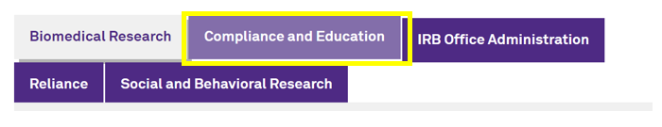

Accessing the Notification Letter
- The notification letter should arrive in the PI and PI Proxy’s email inbox.
  - The Primary Contact for the IRB Project will initially be listed as a PI Proxy for the Compliance Activity.
  - If the notification letter did not appear in the email inbox:
    - Check that the correct email address is listed in the eIRB+ profile.
    - Submit an eIRB+ Support Form request to correct the email address
- The notification letter can be found in the Documents and History tabs of the Compliance Activity.
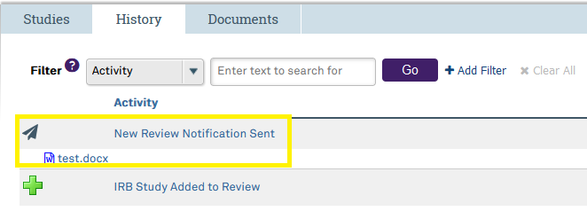

Reviewing the Notification Letter
- The eIRB+ system will send an autogenerated notification email to the PI and PI Proxy(ies) with a notification letter attached that will outline information about the CAPA Plan Assessment post-approval monitoring activity.

Pre-Submission State
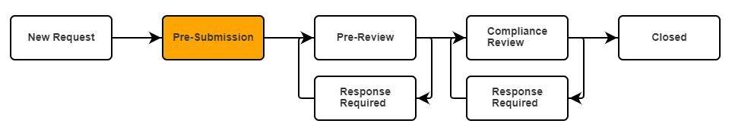
- When the Compliance Analyst sends the notification letter to the PI/Proxy(ies) through the auto-generated eIRB+ notification email, the Compliance Activity is in the Pre-Submission State in the eIRB+ Compliance Workspace. The researcher can access the Compliance Activity from the notification email hyperlink or by navigating to the eIRB+ Compliance Workspace. The Pre-Submission State is pending action/response from the PI or PI Proxy/ies to move forward in the Compliance Activity.
- Within the Compliance Activity, you can see the Response Due Date, the RNI number(s) associated with the Compliance Activity, the CAPA Plan Points, and various other details.
  - CAPA plan points are a summary of the corrective and preventive actions the researcher submitted in the originating RNI. The researcher should respond to each CAPA plan point to provide documentation and confirm whether they completed the corrective and preventive actions as submitted.
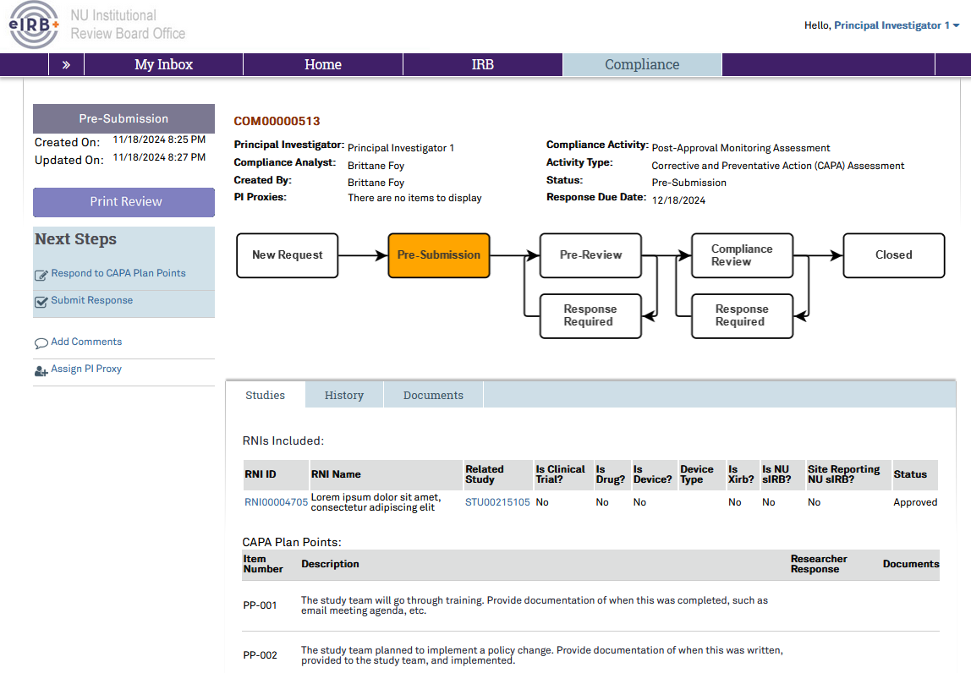

Responding to the CAPA Plan Points
- Select Respond to CAPA Plan Points below Next Steps on the left side menu.
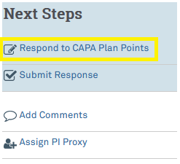
- A pop-up window will appear. Within this window, columns for description, researcher response, and documents can be seen for each CAPA plan point. The researcher response and documents columns will be blank until responses and attachments have been added.
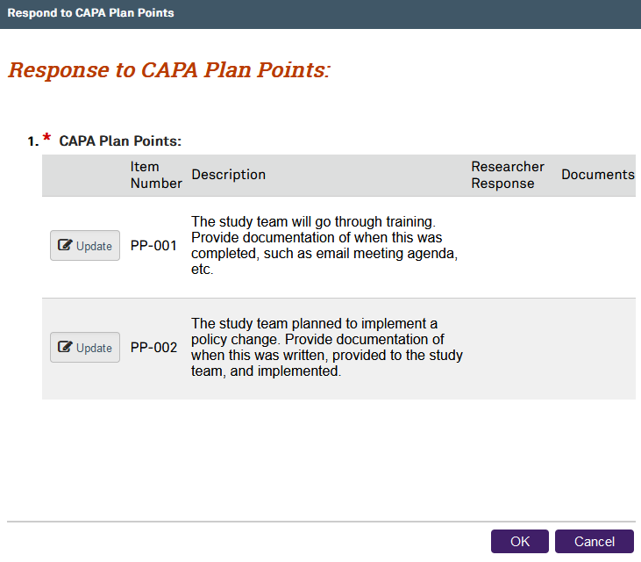
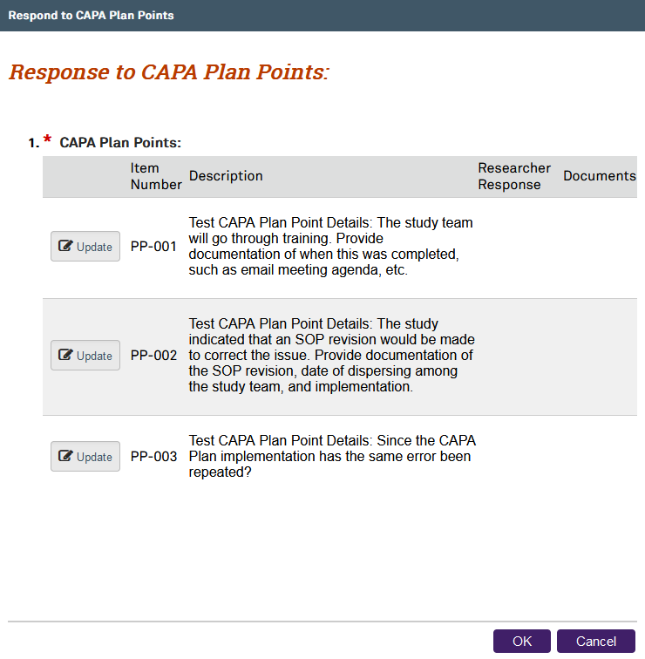
- Select the Update button 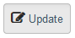to respond to each CAPA plan point.
- Another pop-up window will appear to respond to the CAPA plan point. Within this window, the user may type the response within the Researcher Response textbox and upload any supporting documents by clicking on the +Add button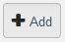.
- In the response the user should indicate progress, implementation, and effectiveness up to date. Documentation to support CAPA plan implementation may include meeting agenda(s), training sign-in sheet, emails, new checklists, processes, or tools.
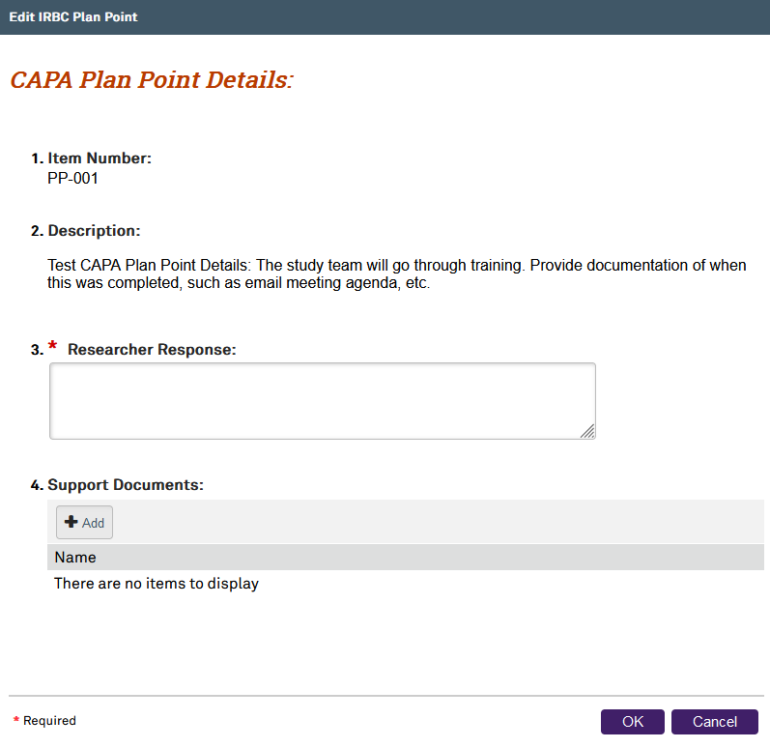
- Click the OK button to continue.
- Progress can be saved, and these steps may need to be repeated to respond to all the CAPA plan points. Any user can edit or update the responses at any time before submitting the response in the next step.

Submitting the Response (Pre-Submission State)
- Once the user responds to all CAPA plan points, click on Submit Response below the Next Steps on the left side menu.
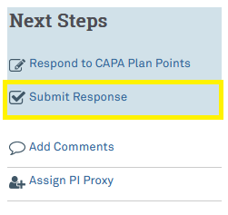
- The PI may delegate PI Proxies to attest that the information provided is true and accurate on behalf of the PI. However, the PI is ultimately responsible for the information provided. A new window will pop up for the PI or PI Proxy to attest to the accuracy of the assessment.
  - If there are CAPA plan points that were not responded to, red text will appear, noting there are CAPA plan points missing responses, and the checkbox for the PI’s attestation will be unclickable. The only option is to select one of the Cancel buttons  or close the window until the user responds to every CAPA plan point.
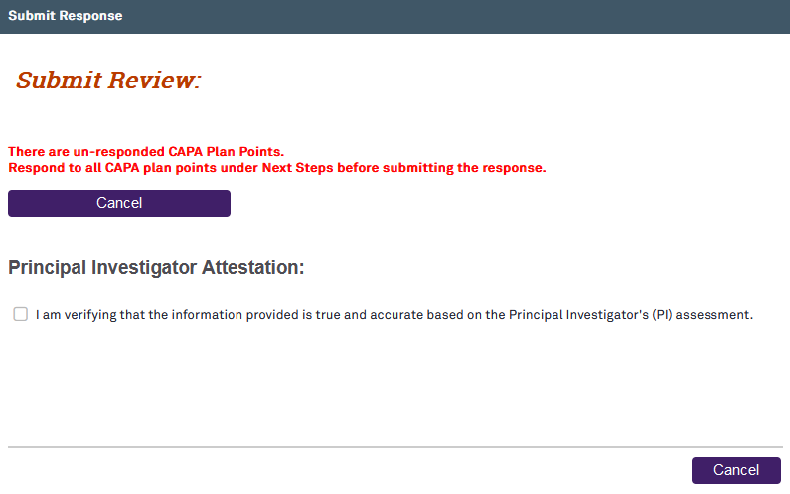
- Click on the checkbox to confirm attestation and the purple OK button to return to the main Compliance Activity page. The eIRB+ system will send an autogenerated email notification to the Compliance Analyst informing them that the Compliance Activity has been submitted for review. The Compliance Activity will no longer be found in the study team’s Compliance Inbox or be available for edits. It will now appear in the My Reviews or All Reviews tabs within the Compliance Workspace. This will end the Pre-Submission State, and the Compliance Activity will enter the Pre-Review State.
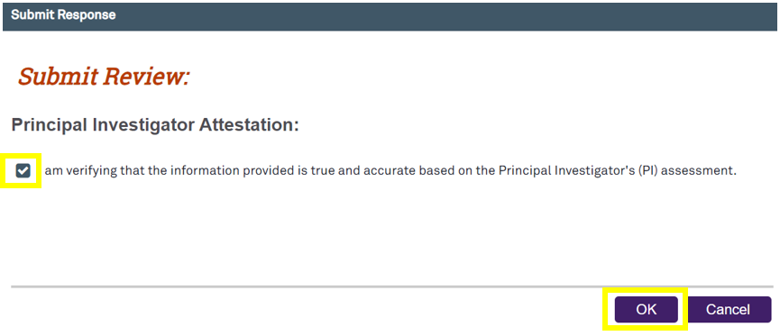

eIRB+ Compliance Tip: Forgot to include some additional information, but already submitted the review?
Users may add comments to the Compliance Activity using the Add Comments icon under Next Steps on the left side menu of the Compliance Activity Page. Users may also email the Compliance Analyst assigned to this Compliance Activity or the IRB Compliance Office.

Pre-Review State
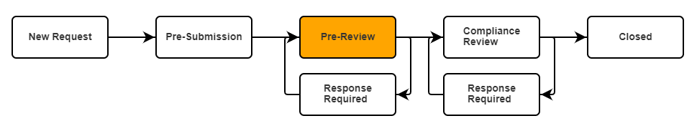
- The Pre-Review State is a state for the Compliance Analyst to ensure the responses are complete, review the study, ask questions, collect information, and provide observations. The Pre-Review State proceeds to the comprehensive Compliance Review State, where the Compliance Analyst provides the researcher with required and/or recommended follow-up actions.
  - While the activity is with the Compliance Analyst in the Pre-Review State, users can still find their Compliance Activity under the My Reviews and All Reviews tab when they log into the Compliance Workspace to check the status.
  - If the PI or PI Proxies need to add additional information after they submit the Compliance Activity back to the Compliance Analyst, they should access the Compliance Activity via the steps above and click on the Add Comments link on the left side menu to add the additional information.
- A Compliance Analyst will review the researcher’s responses to CAPA Plan points in the eIRB+ Compliance Workspace and will send the activity back to the investigator with questions or requests for more information.
  - If the Compliance Analyst does not have any questions about the information provided, the Compliance Analyst will move the activity to the Compliance Review State to assess the CAPA plan implementation and effectiveness (skip to Submitting the Response to the Compliance Analyst).

Response Required (Pre-Review State)
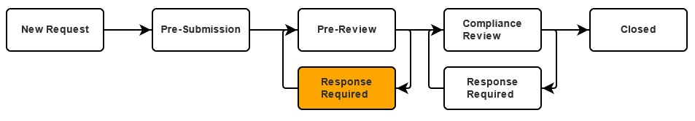
- Once the Compliance Analyst has completed their pre-review and returned the Compliance Activity, the eIRB+ system will send an autogenerated email notifying the PI/PI proxies that the Compliance Activity has been returned. The activity is now in Response Required State awaiting action from the PI/Proxy(ies).

Responding to Observations (Pre-Review State/Response Required)
- Once the Compliance Activity has been returned to the study team, the study team should click on the COM ID within the autogenerated email notification or within the Compliance Workspace Inbox tab to access it.
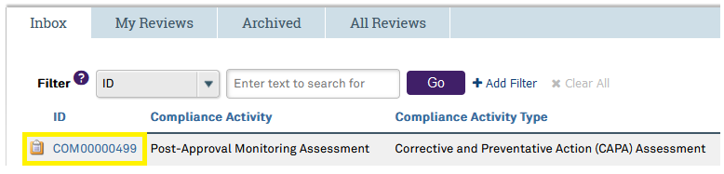
- The observations can be found in the Observations tab of the Compliance Activity.
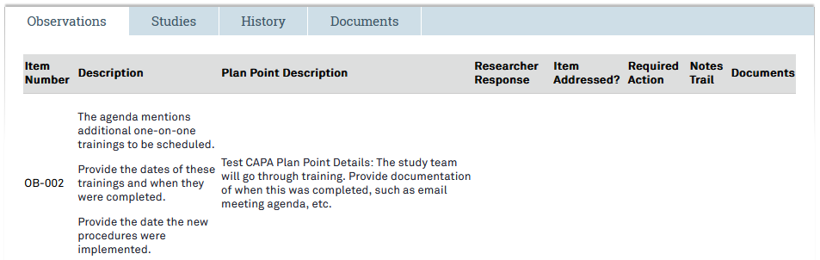
- Click on Respond to Observations  below Next Steps on the left side menu.
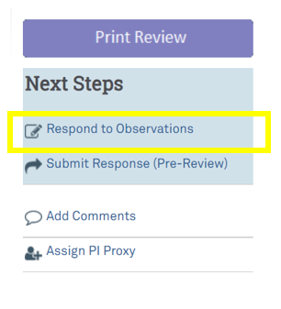
- A pop-up window will appear. Click on each Update button 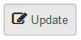 next to each observation to respond.
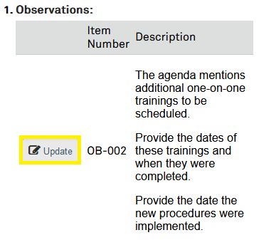
- Another pop-up window will appear to respond to the observation. Within this window, the user may type the response within the Researcher Response textbox and upload any supporting documents (if applicable) by clicking on the +Add button .
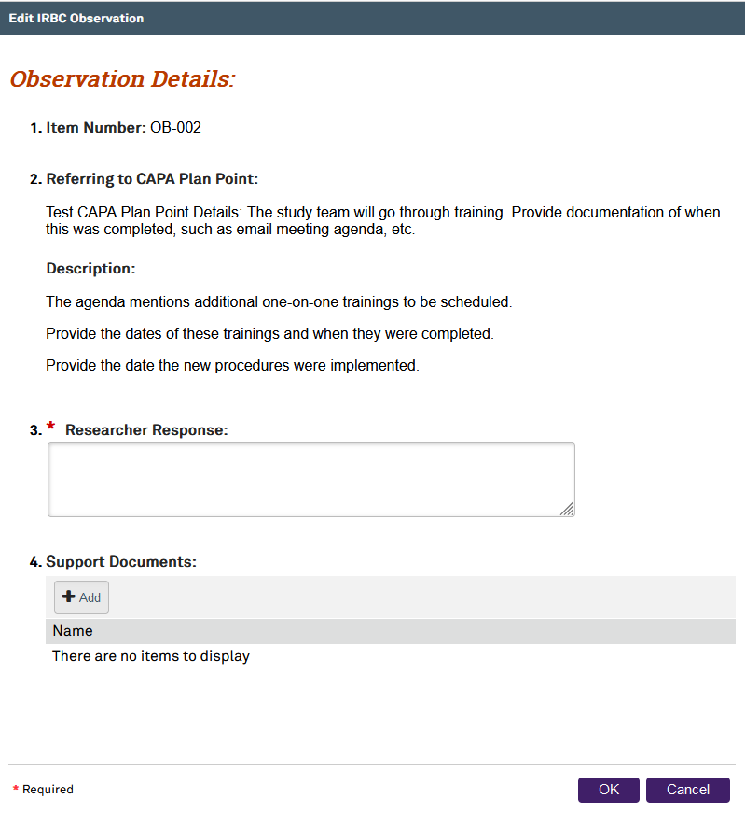
- Click the OK button to continue.
- The user must repeat these steps until they respond to all the observations or if the Compliance Analyst determines any of the responses were not adequate.

Submitting the Response (Pre-Review State)
- Once all the observation responses have been entered, click on Submit Response (Pre-Review) below Next Steps on the left side menu.
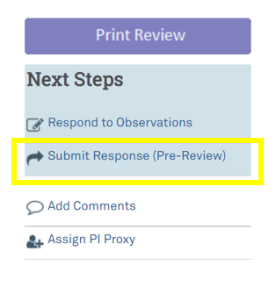
- The PI may delegate PI Proxies to attest that the information provided is true and accurate on behalf of the PIs. However, the PI is ultimately responsible for the information provided. A new window will pop up for the PI or PI Proxy to attest to the accuracy of the assessment.
  - If there are observations that were not responded to, the red text will appear below the attestation, noting there are observations missing responses, and the checkbox for the PI’s attestation will be unclickable. The only option is to select one of the Cancel buttons or close the window until every observation has been responded to.
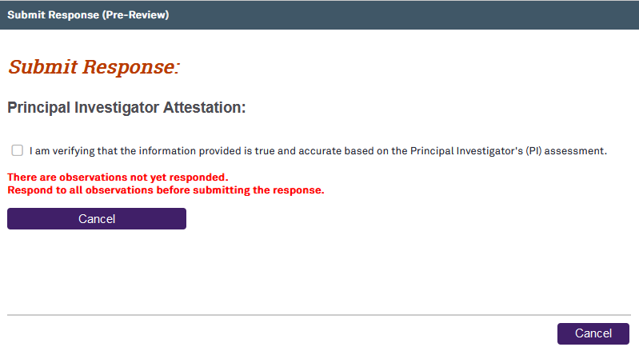
- Click on the checkbox to confirm attestation and the purple OK button to submit the Compliance Activity to the Compliance Analyst through the Compliance Review State and return to the main Compliance Activity page. The eIRB+ system will send an auto-generated email notification to the Compliance Analyst informing them that the user has submitted the Compliance Activity for review. The user will no longer be able to find the Compliance Activity in their Compliance Inbox. The Compliance Activity will now appear in the My Reviews and All Reviews tabs within the main Compliance Workspace page.
- The user may need to repeat the Pre-Review State steps if the Compliance Analyst determines that any of the responses were not adequate.

Compliance Review State
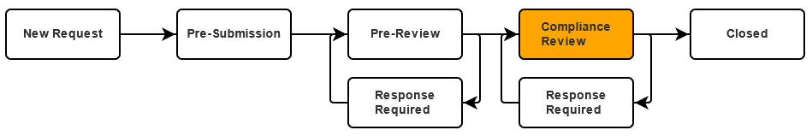
- Once the Compliance Analyst has determined the Pre-Review State responses were adequate (or if they had no Pre-Review State observations), they will move the Compliance Activity into the Compliance Review State. The Compliance Review State is the comprehensive review of the Compliance Activity by the Compliance Analyst. The Compliance Analyst will review the PI’s responses and supporting documents to determine whether any actions are required/recommended. In the Compliance Review State, the Compliance Analyst may provide follow-up actions, education, best practices, etc. If any of the PI’s responses indicate potential non-compliance, the Compliance Analyst will work with the study team to document the event, report the event if it meets IRB reporting criteria per the Incident Assessment Tool (HRP-1207), revise the CAPA plan, or take any additional actions (e.g., submit a Modification). If the Compliance Analyst has any required or recommended follow-up actions, they will send the activity back to the investigator with a description of the request(s).
  - If the Compliance Analyst does not have any required or recommended follow-up actions as a result of the CAPA plan assessment, the Compliance Analyst will send a Compliance Activity Closure notification (skip to Closed Review State).

Response Required (Compliance Review State)
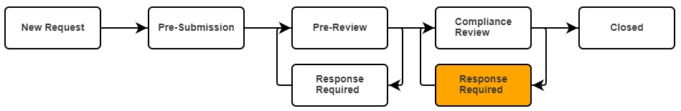
- Once the Compliance Analyst has completed their compliance review and returned the Compliance Activity, the PI and PI Proxy/ies should receive an email notifying them that the Compliance Activity has been returned.
- eIRB+ Compliance Tip: Replying to the auto-generated email notification may result in a delayed response. Contact the Compliance Analyst assigned to the Compliance Activity by clicking on the Add Comments link under Next Steps on the left side menu. Alternatively, Compliance team member contact information is available on the IRB Office website Contact Us page by clicking on the purple Compliance and Education tab.

Responding to Follow-Up Actions (Compliance Review State)
- Click on the COM ID hyperlink in the eIRB+ notification email or within the Compliance Inbox to access the Compliance Activity.
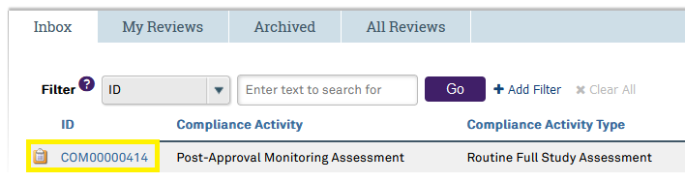
- The Follow-Up Actions can be viewed on the Follow-Up Actions tab of the Compliance Activity. The Follow-Up Actions can only be viewed here.
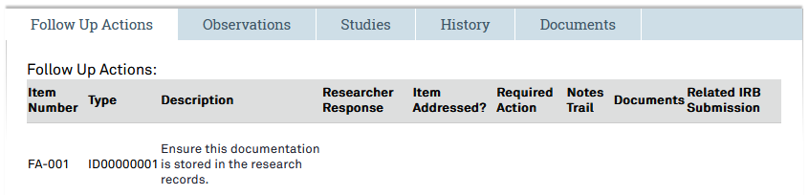
- To respond to the Follow-Up Actions, click on the Respond to Follow-Up Actions link below Next Steps on the left side menu.
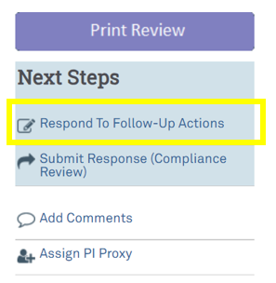
- A new window will pop up. Click on the gray Update button next to each follow-up action to respond.
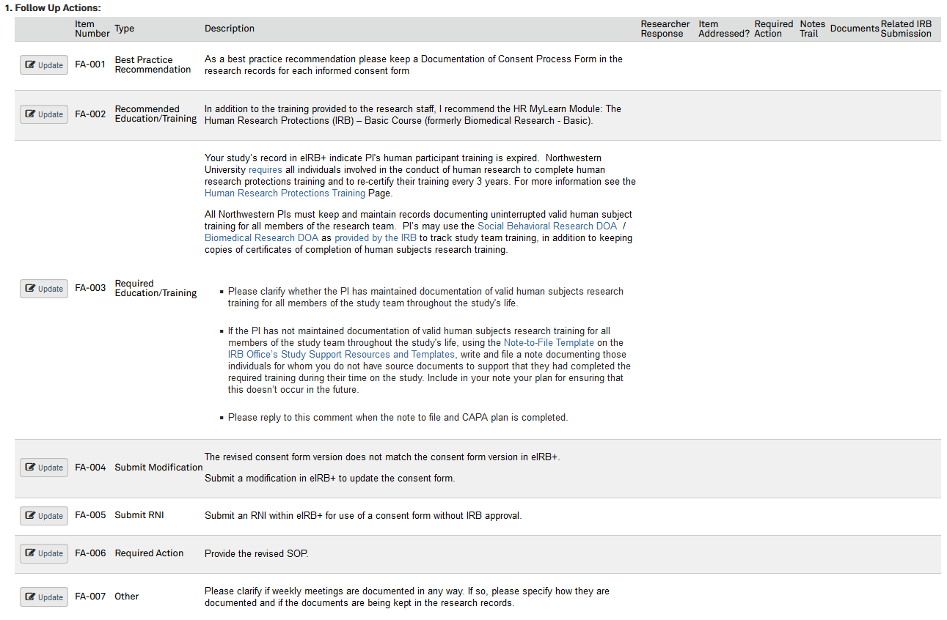
- A new window will pop up. Type a response in the Researcher Response textbox.
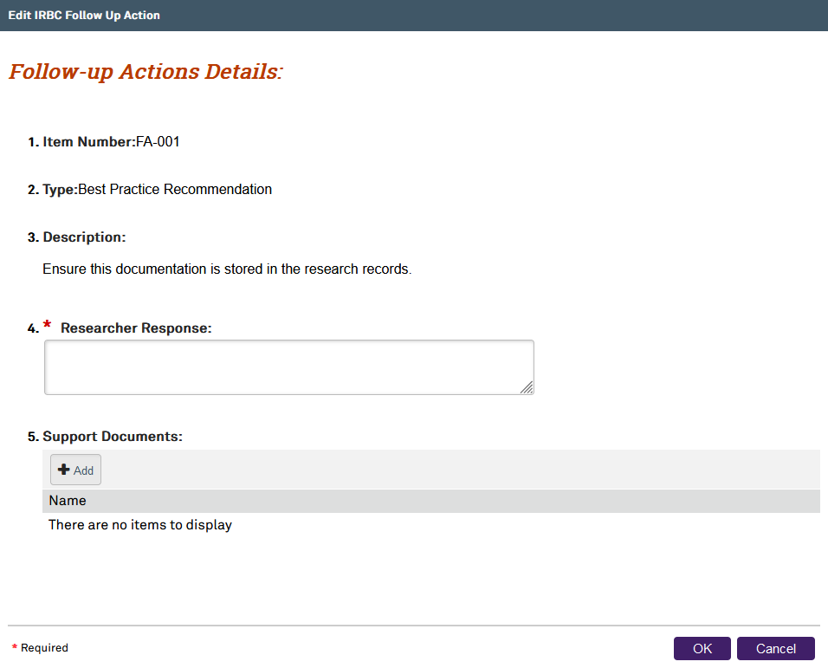
- Add any supporting documents by clicking on the +Add button .
- Click the purple OK button to continue.
- Repeat these steps for all follow-up actions.
- If the Compliance Analyst asks to submit a Closure, Continuing Review, Modification, or Reportable New Information (RNI), the user must create the required IRB submission within eIRB+ prior to responding to the follow-up action. To select a related IRB Submission created to address the request, click on the ellipsis (…) to select the IRB submission.
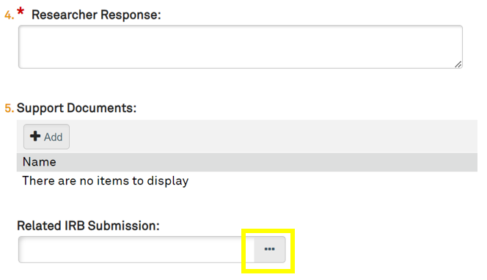
- Click on the purple OK button to continue and close out of the Related IRB Submission selection window.
- Click on the purple OK button to continue and close out of the Follow-up Actions Details window.
- Click on the purple OK button to continue and close out of the Responses to Follow-up Actions window.

Submitting the Response (Compliance Review State)
- Once the user has responded to all the follow-up actions, click on Submit Response (Compliance Review) below Next Steps on the left side menu.
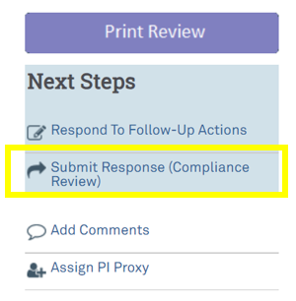
- A new window will pop up for the PI or a PI Proxy to attest to the accuracy of the assessment.
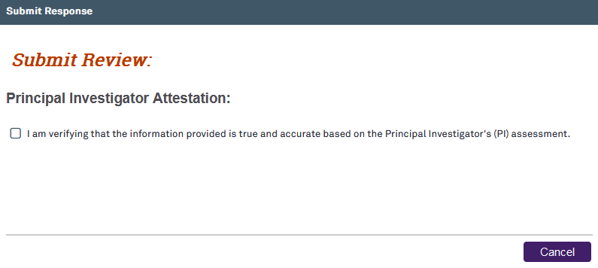
- If the user has not responded to all follow-up actions, a red error message will appear. The user must follow the directions in the Responding to Follow-Up Actions section and return to the Submitting Response section once the user has responded to all follow-up actions.
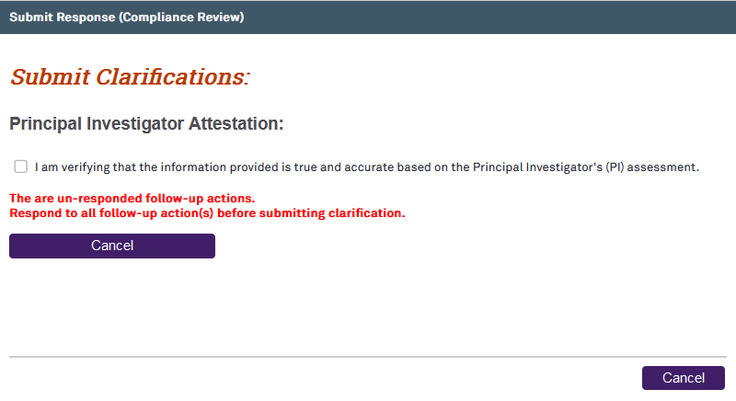
- Click on the checkbox to confirm attestation and the purple OK button to continue.

Closed Review State
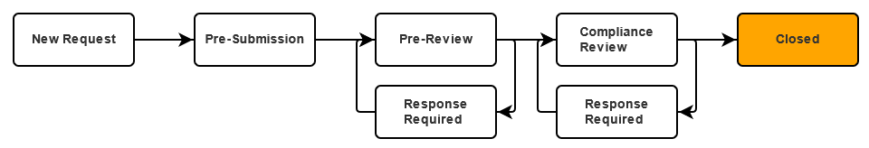
- The Compliance Analyst will close the Compliance Activity and send a PAM Closure Letter once the user has responded to and addressed all the observations and follow-up actions (or if the Compliance Analyst has no observations or follow-up actions). Once the Compliance Analyst closes the Compliance Activity, the eIRB+ system will send an auto-generated email notification to the PI and PI Proxy(ies) with the closure letter attached. At this point, the user should follow the directions in the section titled “Saving the Required Documentation from the Compliance Activity” below. The CAPA Compliance Activity is now complete.

Accessing Completed Compliance Activities
- The user can access completed compliance activities through the link in the eIRB+ auto-generated email notification. To access completed compliance activities from the Workspace, click on the Compliance tab when logged into eIRB+.
- Click on the Archived tab. The COM ID may be entered into the search box and click the purple Go button. Or, scroll down to find and select the correct COM ID.
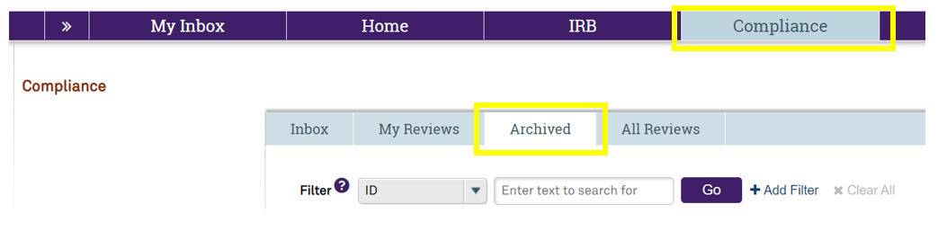

Accessing the PAM Closure Letter
- The PAM Closure letters generally contain education relevant to the status of the ongoing conduct of the study such as document retention and study closure guidance and other tailored resources and education. The Closure letter will be available as an attachment in the email notification automatically generated when the Compliance Activity is closed. To access and download the PAM closure letter from the eIRB+ Compliance Workspace, click on the Documents tab.
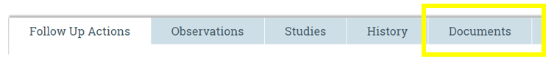
- From there, the study team will be able to download the associated PAM correspondence, including the notification and closure letter.
  - Note: documents uploaded to observations and follow-up actions are available in the corresponding tabs (i.e., Observations and Follow-Up Actions), not in the Documents tab. The Principal Investigator should save all documents related to compliance activities in their study file.

Accessing the Compliance Activity Print Review Page
- The Print Review Page will allow the study team to view the entire Compliance Activity on one page.
- From the main Compliance Activity page, click on the purple Print Review button  on the left side menu. It will take you to the Print Review page, where you can then select the purple Print button at the top to print the entire Compliance Activity with all the completed checklists.

Saving the Required Documentation from the Compliance Activity
- After the Compliance Activity has been closed, it is required that the Principal Investigator save a copy of the Compliance Activity and associated documents to their research records. Print or save the electronic copies of the notification letter, closure letter, and Compliance Activity Print Review page to the study’s research records.
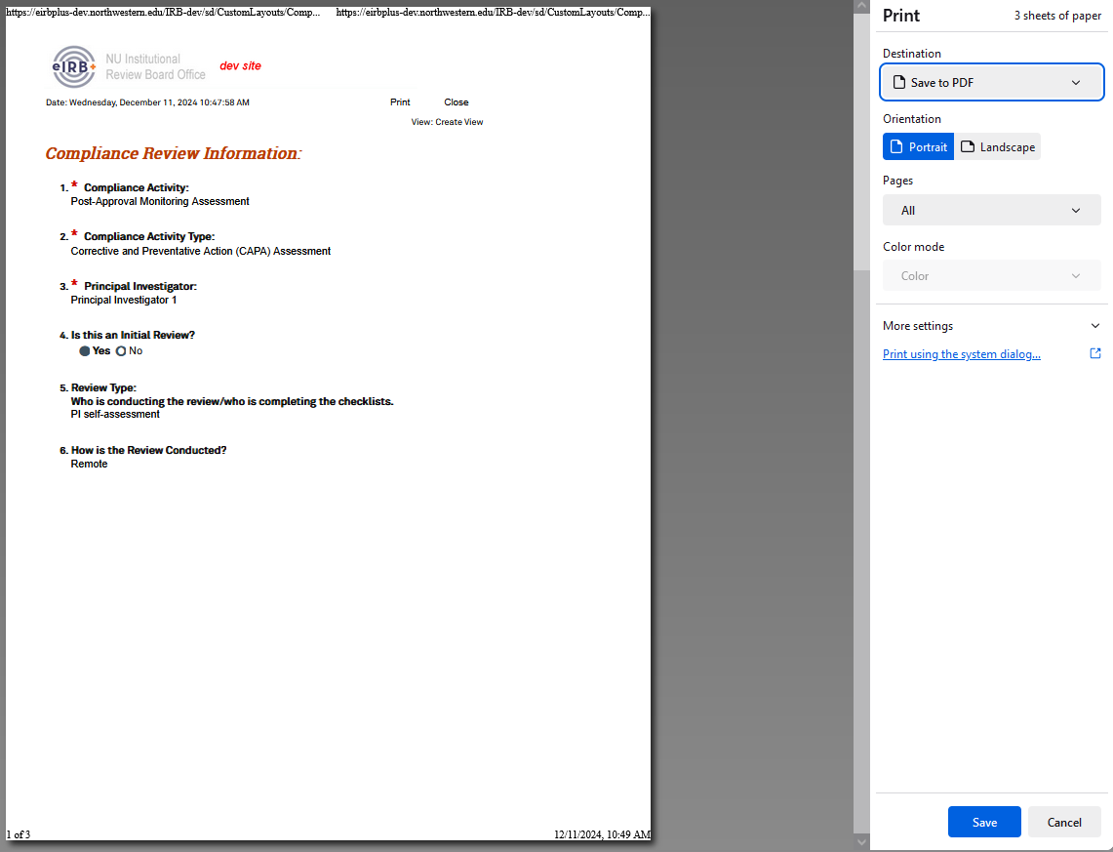
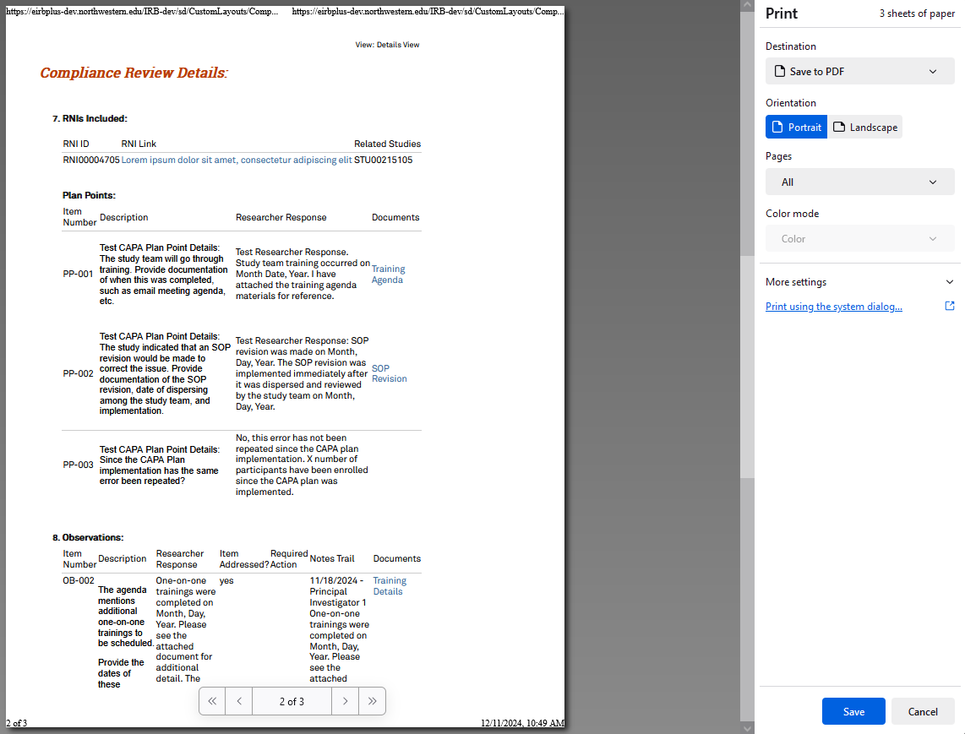
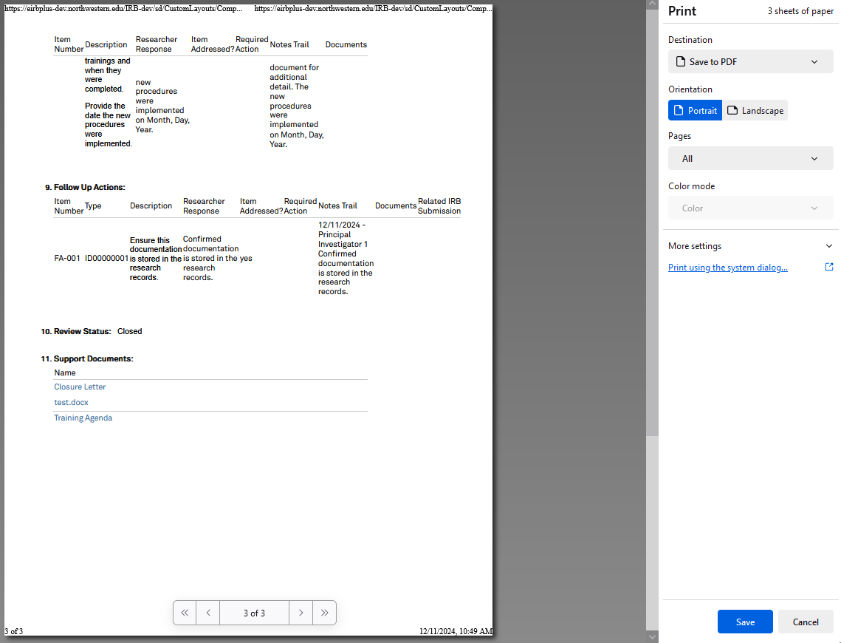

- eIRB+ does not serve as an electronic version of the study files. The regulatory binder (where all documents related to the study are kept) should be centralized and can be maintained within an electronic format (saved PDFs and Word/Excel documents) or within a binder (printed paper copies). See the IRB Office’s Study Support Resources and Templates Page for the Regulatory Binder and Research Record templates.
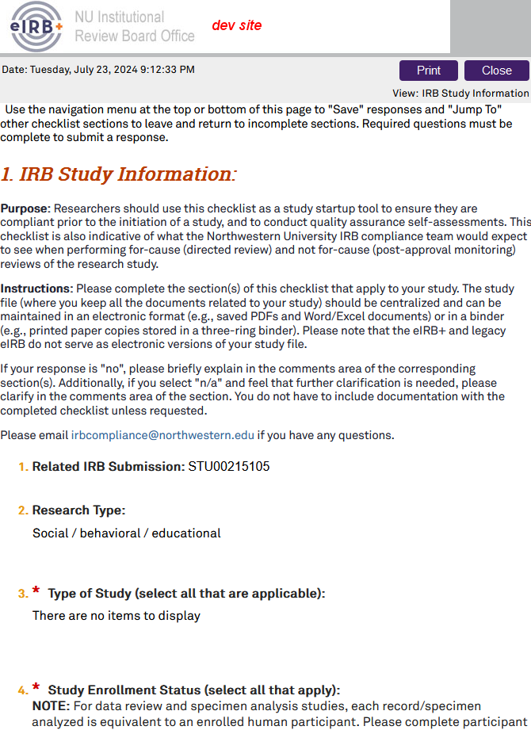
  - Selecting the Print button will open the print screen where the user can choose to print or save a PDF copy.
  - Selecting the Close button will return to the Compliance Activity page.

