eIRB+ Tutorial:

Getting Started for the Research Community
Contents
Getting Started 2
Logging into the eIRB+ Compliance Workspace 2
Navigating the Compliance Workspace 2
Navigating to the Compliance Activity 6
Compliance Activity Access (PI Proxy) 11
Adding Comments and Supporting Documents 16
Using the Checklist Navigation Panel 20
Checklist Functions 22

Getting Started

Logging into the eIRB+ Compliance Workspace
- Navigate to eIRB+ at https://eirbplus.northwestern.edu/
  - On-campus users can access the system directly while connected to University-provided internet.
  - To access eIRB+ off-campus, the user will need to first connect to the VPN or web VPN.
- eIRB+ requires a University NetID and Password to log in.
  - New to eIRB+? All users must register first.
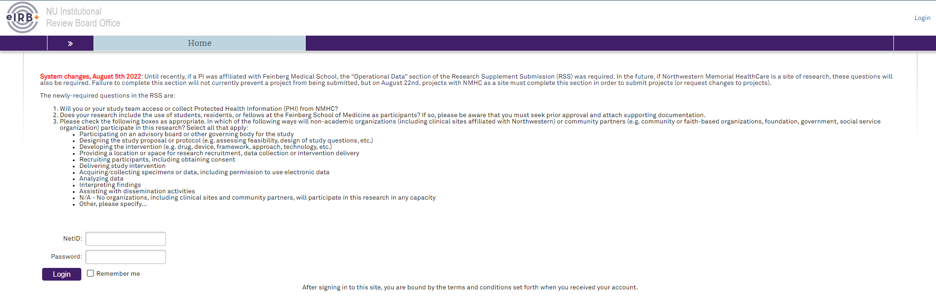

Navigating the Compliance Workspace
- Select the Compliance section 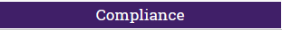 on the purple navigation bar to access the eIRB+ Compliance Workspace.

- The Compliance Workspace is divided into 4 tabs:
  - Inbox Tab
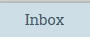
    - This tab shows the active compliance activities that require an action from the user.

  - My Reviews Tab
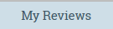
    - This tab shows all active compliance activities the user has access to, including activities that require action from either the user or the Compliance Team.

  - Archived Tab
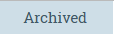
    - This tab shows completed/closed or discarded compliance activities the user has access to.

  - All Reviews Tab
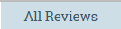
    - This tab shows all active and archived compliance activities the user has access to.

- Each tab in the Compliance Workspace shows the following categories of information for each Compliance Activity:

  - ID Column
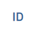
    - This column lists the unique identifier (ID) for the Compliance Activity. The Compliance Activity ID begins with “COM” followed by an 8-number code that is unique to each compliance workspace activity—for example, COM00000123.
      - The COM# serves as a hyperlink to access the Compliance Activity.

  - Compliance Activity Column
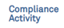
    - This column describes the main category of the Compliance Activity, e.g., Post-Approval Monitoring Assessment.

  - Compliance Activity Type Column
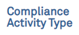
    - This column describes the subcategory of the Compliance Activity, i.e., the type of review that is being conducted.
      - Subcategories for Post-Approval Monitoring Assessment reviews:
        - Routine Full Study Assessment
        - New Investigator Assessment
        - Study Status Assessment
        - Corrective and Preventative Action (CAPA) Assessment
        - Other

  - Studies Column

    - This column lists the IRB STU number(s) (i.e., study/ies) associated with the Compliance Activity.

  - PI First Name Column
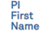
    - This column lists the first name of the PI associated with the study/ies related to the Compliance Activity.

  - PI Last Name Column
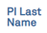
    - This column lists the last name of the PI associated with the study/ies related to the Compliance Activity.

  - Status Column
    - This column indicates the current state of the Compliance Activity.
      - The states for a Post-Approval Monitoring Assessment Review are:
        - New Request
        - Pre-Submission
        - Pre-Review
        - Response Required (Pre-Review)
        - Compliance Review
        - Response Required (Compliance Review)
        - Closed
      - The Post-Approval Monitoring Assessment Review states are also shown within the Compliance Activity visual:
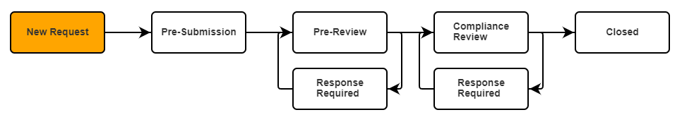

  - Date Modified Column
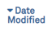
    - This column shows the most recent date the Compliance Activity was updated or modified.

- Within each of the Compliance Workspace tabs, the user may filter the Compliance Activity items by the ID (COM#), Compliance Activity, Compliance Activity Type, Studies (STU#), PI First Name, PI Last Name, Status (of the Compliance Activity), or Date Modified.
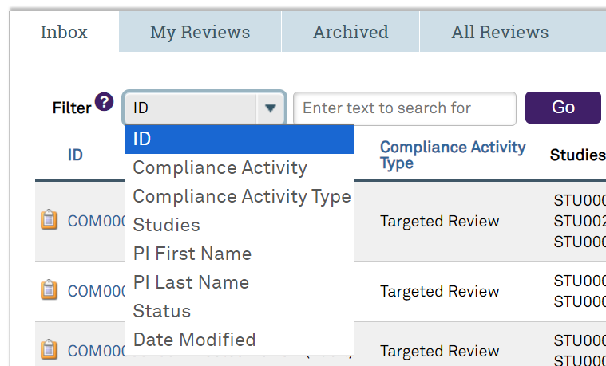
  - For additional help with using the search function efficiently, please click on the Question Mark icon . A box will pop up with tips on how to enter text that will efficiently filter the information categories.
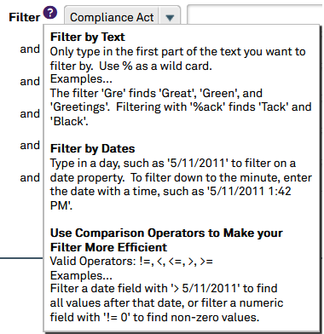

Navigating to the Compliance Activity
- There are two pathways to access the Compliance Activity:
  - Click on the COM# hyperlink in the notification email.
OR
  - Find the Compliance Activity within the Compliance Workspace under the Inbox tab. Selecting the COM# under the ID column will open the Compliance Activity submission. (If the COM# is not in the Inbox, then an action is currently not required within the activity. Check the All Reviews tab to find the activity in any state.)
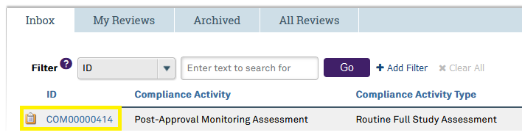

- The specific Compliance Activity page provides information about the activity creation date, the last updated date, PI, assigned Compliance Analyst, the Compliance Analyst that created the activity, PI Proxies, Compliance Activity, Activity Type, Status, Response Due Date, and an active workflow indicating the current status.
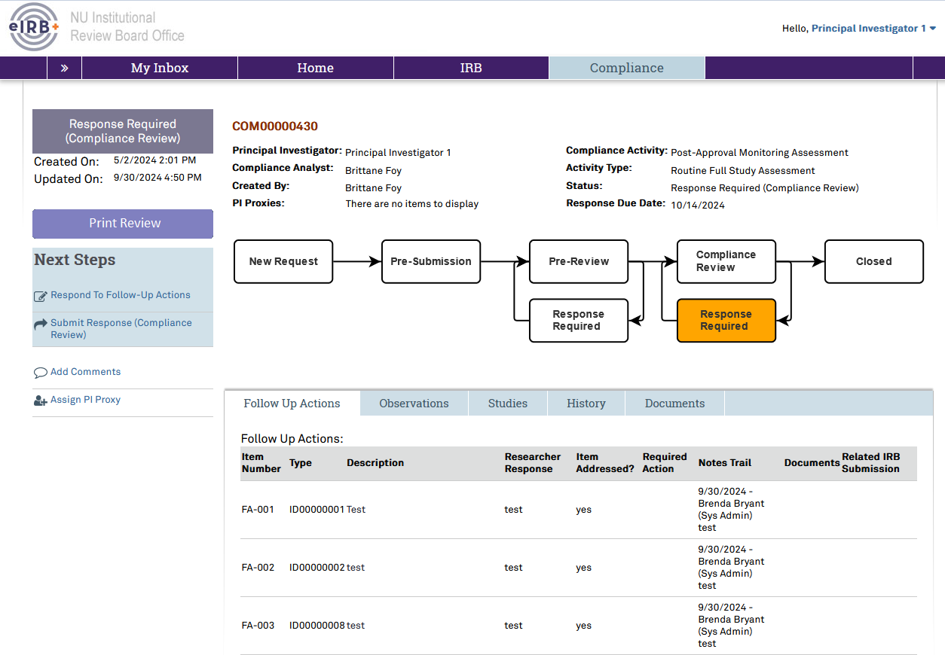
  - Each Compliance Activity contains information in the following tabs:
    - Studies Tab
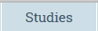
      - This tab outlines details for each study related to the Compliance Activity. Some of this information is pulled from the IRB submission and some of this information will populate based on responses entered in the checklists (i.e., Type of Study).
      - Find the Post-Approval Monitoring checklists under this tab by clicking the View/Edit Checklist button .
    - History Tab
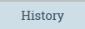
      - This tab keeps a record of notifications, actions, and communications related to this specific Compliance Activity and provides links to the documents associated with the actions.
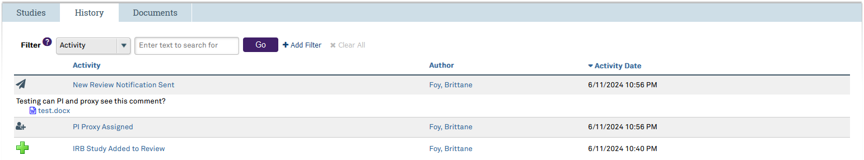
      - Clicking on an action under the History Tab will open the Activity Details page associated with that action.
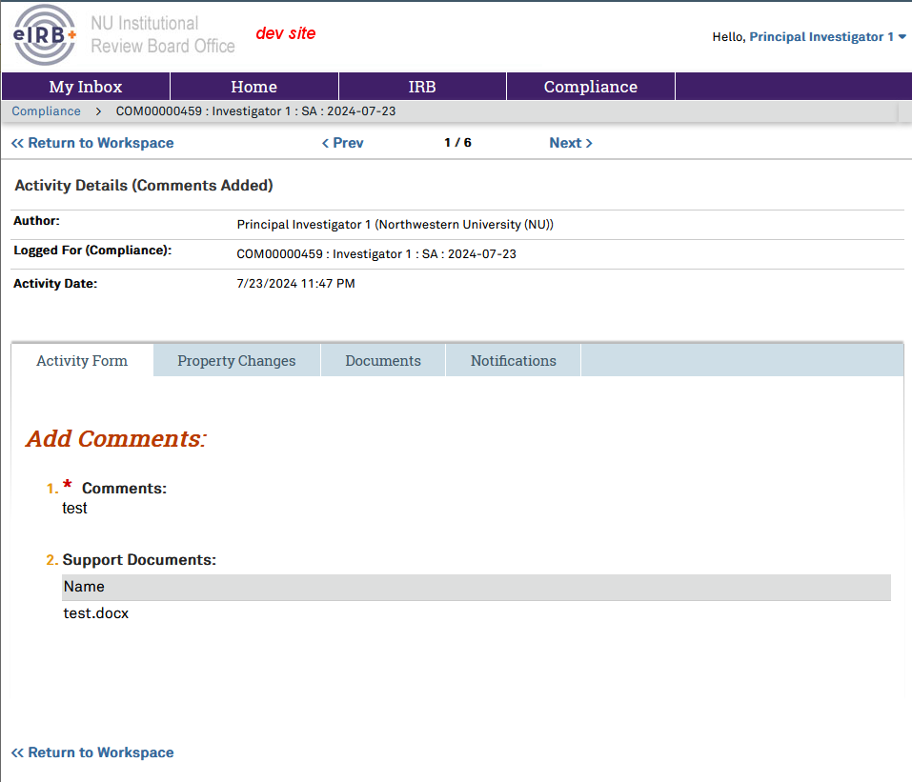
        - The header of the page summarizes the action (action type, who completed the activity, the COM#, and the date the action was completed). The tabs underneath contain the details. Click “Return to Workpace” to go back to the main Compliance Activity page.
          - Activity Form Tab displays the information as entered into the pop window previously filled out to complete the action.
          - Property Changes Tab contains technical information about how the action changed the Compliance Activity. (For example, for an action “PI Proxy Assigned”, this tab will show the names of the individuals added and/or removed as PI Proxy within that action at that date and time.)
          - Documents Tab contains links to the documents attached to the action (if any). These are the same documents visible for the action on the History tab. If there are no documents associated with the action, this tab is blank.
          - Notifications Tab contains information about the email notification sent for the associated action, including the email Subject, To: Recipients and emails, and Cc: Recipients and emails. If the activity did not generate an email notification, this tab is blank.

    - Documents Tab
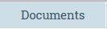
      - This tab lists all documents uploaded in the History tab for the Compliance Activity.
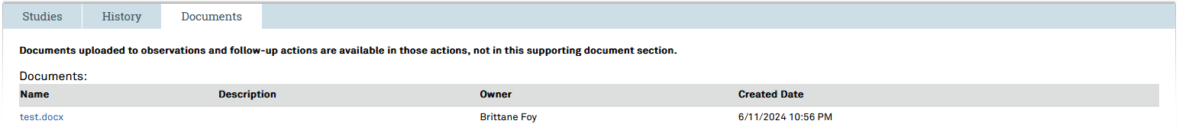
    - Observations Tab
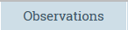
      - This tab will not appear until the Compliance Activity reaches the Pre-Review state.
      - This tab lists the Compliance Analyst’s initial observations after they complete their review of the submitted Post-Approval Monitoring checklists. Each observation is listed by Item Number (OB-0##), Description, Researcher Response, Item Addressed?, Required Action, Notes Trail, and Documents, with information filling in each column as each observation is addressed. This tab will be empty if no observations have been made.
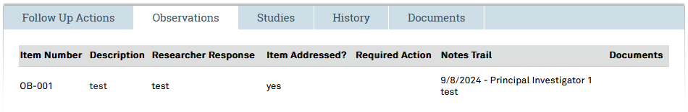
    - Follow Up Actions Tab
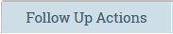
      - This tab will not appear until the Compliance Activity reaches the Compliance Review state.
      - This tab lists the Compliance Analyst’s requested follow-up actions based on their review of the completed Post-Approval Monitoring checklists and any clarification provided within the observations. It will list the Item Number (FA-0##), Type, Description, Researcher Response, Item Addressed?, Required Action, Notes Trail, Documents, and Related IRB Submission. This tab will be empty if no observations have been made.
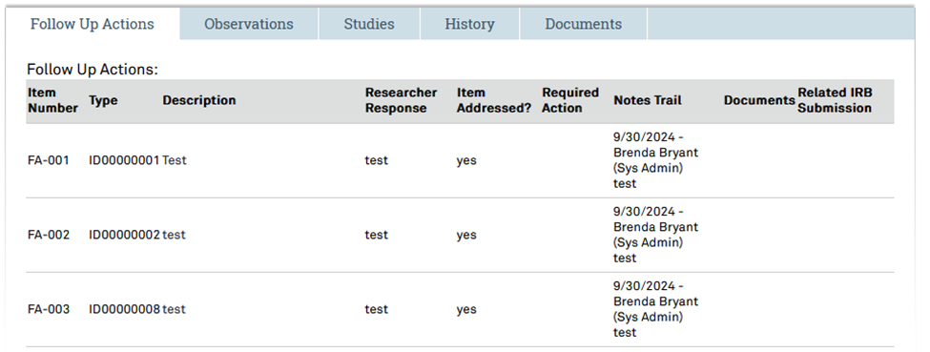
  - Next Steps Window
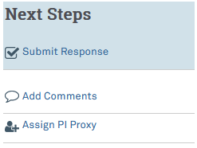
    - The window on the left side of the Compliance Activity Page indicates the Next Step that can be taken. Items in the blue shaded box are actions related to moving the Compliance Activity along in the workflow. Items below the blue shaded box are unrelated to advancing the workflow and are administrative in nature.
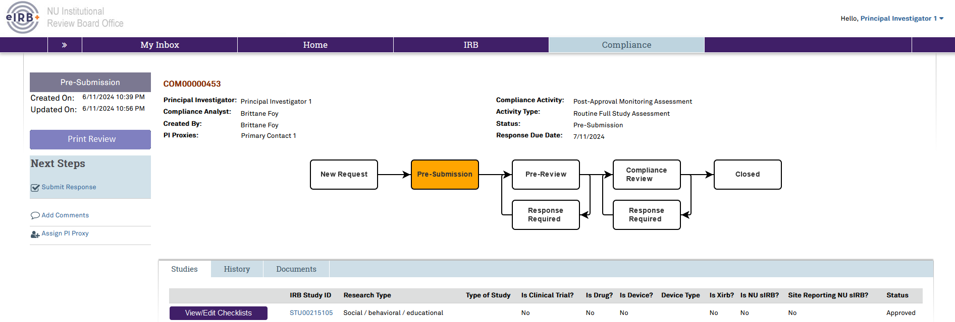
    - Next Step Actions:
      - Submit Response
        - This item will ask for the PI or PI proxy to attest that the responses provided are true to their knowledge. After this attestation, the submission will enter the Pre-Review state, where the Compliance Analyst will take action. The Compliance Analyst will receive a notification that this Compliance Activity is available for their review.
      - Add Comments 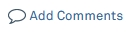
        - This item will enter comments into the History tab that the Compliance Analyst and anyone else with access to the activity may see. Adding a comment will also automatically generate an email to the PI, all PI Proxies, and the Compliance Analyst, displaying the text of the comment.
      - Assign PI Proxy
        - This item will allow approved individuals to provide PI Proxy status to others to access the Compliance Activity, receive Compliance Activity notifications, edit the Compliance Activity, and submit responses within the Compliance Activity.

Compliance Activity Access (PI Proxy)
- PI Proxy status allows individuals to access the Compliance Activity, receive Compliance Activity notifications, edit the Compliance Activity, and submit responses within the Compliance Activity. These permissions cannot be separated.

Initially, the Principal Investigator (PI) is the only user who can access the Compliance Activity and to whom the system will send notifications about the activity. The assigned Compliance Analyst will include the related study’s IRB Primary Contact as a PI Proxy if different from the PI. If someone else needs access to view or take action within the Compliance Activity, the PI or anyone else with PI Proxy status for that specific Compliance Activity is responsible for granting those individuals PI Proxy status. Any user registered in eIRB+ may be granted PI Proxy status, and there is no limit on the number of PI Proxies. Permissions from the associated study do not transfer to nor restrict permissions for the Compliance Activity. Permissions from one Compliance Activity do not transfer to nor restrict permissions for another Compliance Activity.

  - Steps to Add PI Proxy:
    - Click the Assign PI Proxy icon under the Next Steps window on the left side of the Compliance Activity Page to open the Assign PI Proxy window.
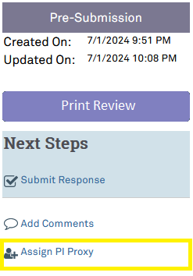
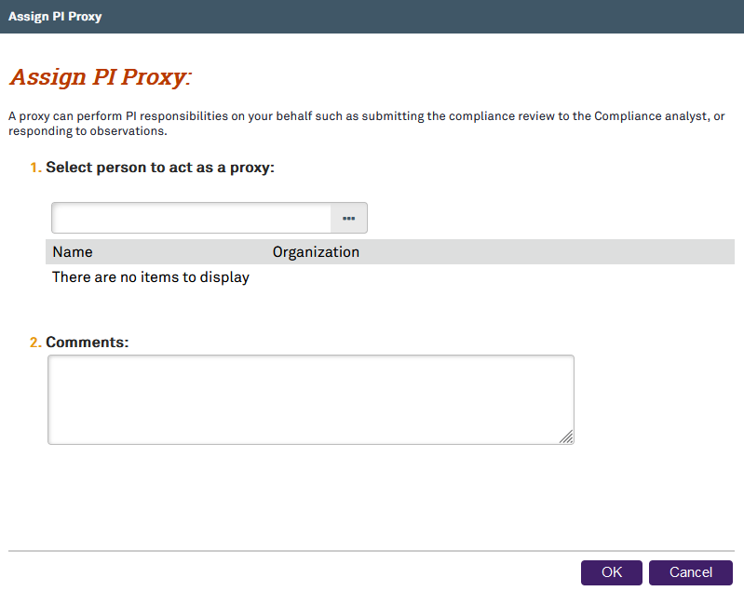
    - The user may type the name of the individual they wish to grant PI Proxy status or click the ellipsis button 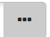 to open the Select One or More Persons search window.
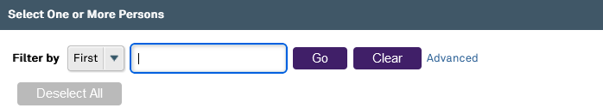
    - The user may filter their search by first or last name.
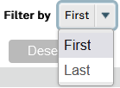
    - Add comments to the Comments text box if needed.
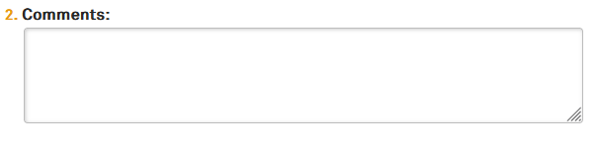
      - Visibility Note: The Compliance Analyst and PI/PI Proxy can see the comments entered here in the activity’s History tab.
    - Once the user has entered the first or last name, click the Go button to search for the individual(s).
    - Select the check box(es) button(s) for the required individual(s).
    - Select the OK button 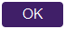 after selecting the required individual(s).

    - The selected individual(s) will now have PI Proxy status, which means they can see the Compliance Activity and receive email notifications related to it. The action of adding PI Proxy(ies) and the associated comment(s) will appear as “PI Proxy Assigned” under the Activity column in the history tab.
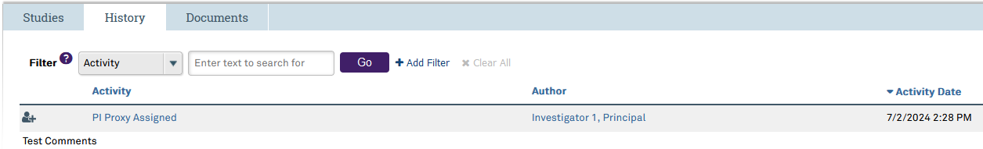

  - Steps to Remove PI Proxy:
    - Click the Assign PI Proxy icon under the Next Steps window on the left side of the Compliance Activity Page to open the Assign PI Proxy window.
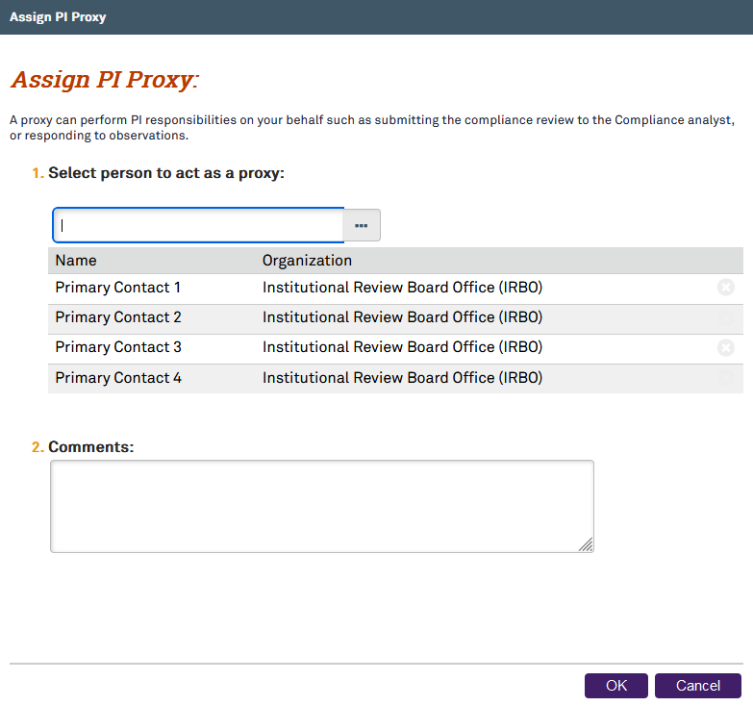
    - Locate the name of the individual in the list, and click on the X button at the end of the row on the right of their name. The X button will be light grey until the cursor is hovering over the row for the individual’s name.
    - Then, select the OK button for the Compliance Activity page to refresh with the updated information, removing the specific personnel from having PI Proxy status.
    - The action of removing PI Proxy(ies) and the associated comment(s) will appear in the history tab. Removal or addition of PI Proxy(ies) will appear as “PI Proxy Assigned” under the Activity column in the History tab .
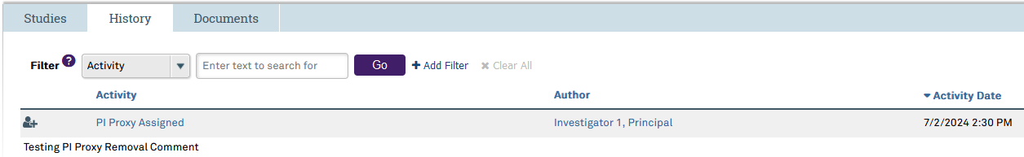

Adding Comments and Supporting Documents
- There is an option to add comments regarding the Compliance Activity.
  - Click the Add Comments icon 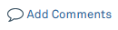 under the Next Steps window on the left side of the Compliance Activity Page to open a new Add Comments window.
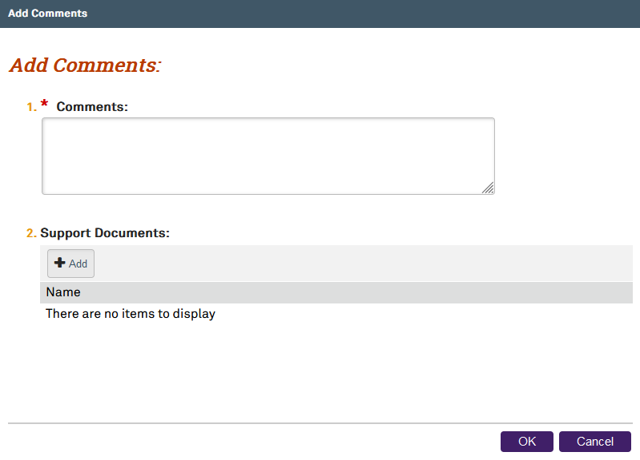
    - Type the comment in the textbox under item 1.
    - Upload supporting documents, if any, in item 2.
      - There are two options to add supporting documents:
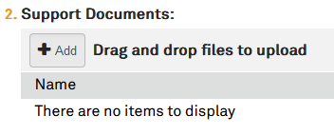
        - Documents may be dragged and dropped into the Add button 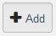 section. Documents that are uploaded via drag and drop will be given the same title as the document file name.
OR
        - Select the Add button to open a new Submit a Document Window.
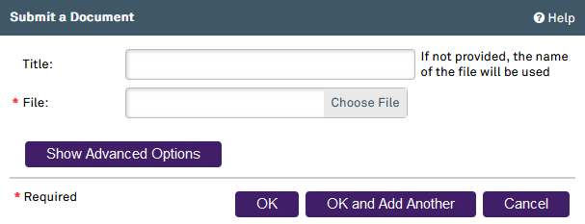
          - Type the document title in the Title field. If a title is not entered in this field, the file name will be used as the title.
          - Select the Choose File icon 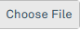 to open Windows Explorer to locate the document to upload.
          - Select the OK button to go back to the Add Comments window with the added document now displayed in item 2.
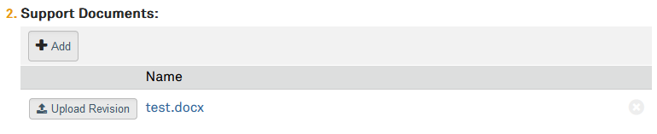
            - The Upload Revision button 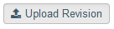 may be utilized when an incorrect document has been uploaded or a new version of the document should replace the document currently uploaded.
              - Selecting the Upload Revision button will open the Submit a Document window. This window will be pre-populated with the original document title. However, this may be changed. Upload the revised document.
                - Type the document title in the Title field. If a title is not entered in this field, the file name will be used as the title.
                - Select the Choose File icon to open Windows Explorer to locate the document to upload.
                - Select the OK button to go back to the Add Comments window. The revised document will now displayed in Section 2, replacing the original document.
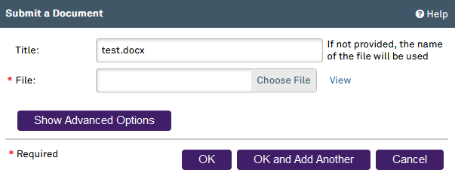
          - Selecting the OK and Add Another button will add the selected document to the Add Comments window and leave the Submit a Document window open to add another document.
          - Selecting the Cancel button 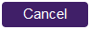 will return to the Add Comments window with no documents added.
          - Select the OK button after inputting the comment and supporting documents into the Add Comment window. This will add the comment and supporting documents to the History tab and send an email notification to the PI, all PI Proxies, and the Compliance Analyst assigned to this Compliance Activity.
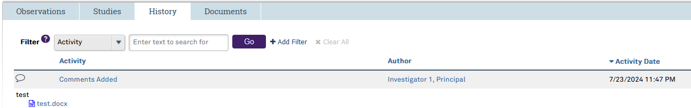
  - Select the Cancel button to discard the comment and return to the main page for this Compliance Activity.

Using the Checklist Navigation Panel
- The Navigation Panel is located at the top and bottom of each checklist page.
- The Back 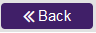 and Continue buttons allow the user to move forward or backward through the checklist pages.
    - The Back button will go back to the first page that has validation errors. It will not always go back to the page directly before the one the user is currently on.
    - The Continue button will only take the user to the next page if the current page is complete and showing no validation errors.
    - Validation errors are error warning messages that will appear when required items are incomplete.
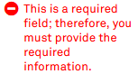
  - Selecting the Save icon will save the study team’s progress.
  - The Hide/Show Errors icon will toggle validation errors. Selecting the Hide/Show Errors icon will switch between showing or hiding the validating errors. Validation error messages will appear in the bottom half of the page window.
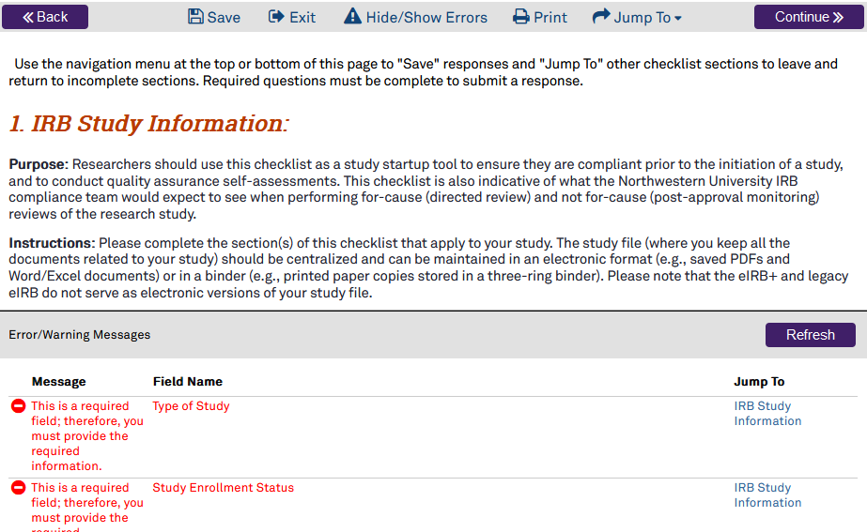
    - The Refresh button will refresh the Error/Warning Messages.

  - The Jump To icon will allow the user to navigate to any checklist page regardless of validation errors.
    - Selecting the Jump To icon will display the complete list of clickable checklist pages for the user to select.
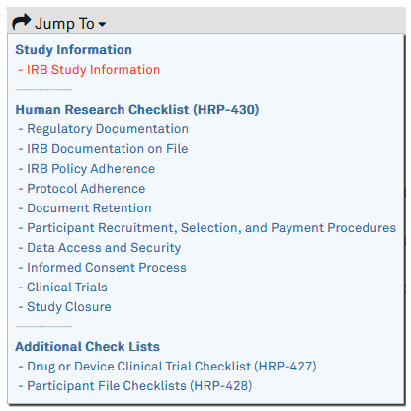

Checklist Functions
  - The red asteriskmeans the field is required.
    - Selecting the Continue button in the Navigation Panel at the top right or bottom right of the page without completing the required fields will trigger the system to prevent the user from continuing. The system will populate the following message after each required field on the page that is incomplete, “This is a required field; therefore, you must provide the required information.”
    - Selecting “Jump To” in the Navigation Panel at the top or bottom of the page will allow the user to leave the page they are currently on and jump to another desired section even if the user has not completed all the required fields.
eIRB+ Compliance Tip: The information previously entered on the page before jumping to another section without selecting “Save” will not be lost; however, it is highly recommended to save often to avoid potentially losing responses.
    - Contact the assigned Compliance Analyst or email irbcompliance@northwestern.edu with any questions about how to answer an item.
  - Radio buttonsmean only one item may be selected.
  - Selecting the Clear button will reset or clear the selections made for that item.
  - Checkboxes mean multiple items may be selected.
  - Textbox fields 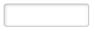 allow typed entries.
    - If there are diagonal lines in the bottom right corner of the textbox field, the textbox may be expanded using click and drag.
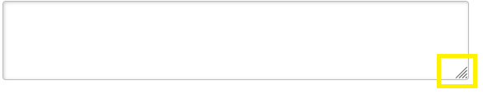
  - The Add button opens another window to add entries to specific fields.
  - The drop-down menu 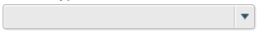 allows the user to select one item.
  - The calendar menu 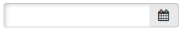 allows the user to type a date into the field or the date can be selected by clicking on the calendar icon to open the calendar.
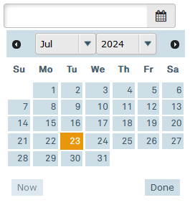
    - The calendar will open with the current date selected.
    - Once the calendar is open, the user can select the date by clicking on it.
    - The circled arrows will take the user back or forward a month depending on the arrow selected.
    - The month and year drop-down menus will open a list to select the desired month or year.
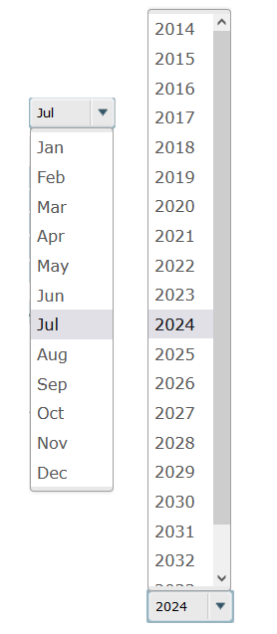
    - The Now button  will select today’s date.
    - The Done button 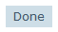 will close the window and populate the field with the date selected.
  - Comment boxes allow for typed entries.
    - Visibility Note: Comments entered here are visible to the PI/PI Proxy and the Compliance Analyst.
  - The Finish button 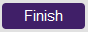 will appear at the end of the checklist. Select Finish when the checklist is complete to save entered responses and take the user back to the main Compliance Activity page.
    - Selecting the Finish button will NOT submit the activity to the Compliance Analyst. The user must select the Submit Response Icon from the Compliance Activity page to route the activity to the Compliance Analyst for review.

