eIRB+ Tutorial:

Self-Assessment for the Research Community

Contents
Contents 1
Post-Approval Monitoring (PAM) Assessment Activities 3
Compliance Activity Notification 3
Accessing the Notification Letter 3
Reviewing the Notification Letter 4
Pre-Submission State 4
Completing the PAM Assessment Checklists 4
View Edit/Checklists 4
Using the Navigation Panel 5
Checklist Functions 9
Submitting the Checklists 10
Pre-Review State 11
Response Required (Pre-Review State) 12
Responding to Observations (Pre-Review State) 12
Submitting the Response (Pre-Review State) 14
Compliance Review State 16
Response Required (Compliance Review State) 17
Responding to Follow-Up Actions (Compliance Review State) 17
Submitting the Response (Compliance Review State) 21
Closed Review State 22
Accessing Completed Compliance Activities 23
Accessing the PAM Closure Letter 23
Accessing the Compliance Activity Print Review Page 23
Saving the Required Documentation from the Compliance Activity 23

Post-Approval Monitoring (PAM) Assessment Activities
- Post-approval monitoring (PAM) is a routine compliance review of IRB-approved studies that is collaborative and education-focused to help improve research practices and protect research participants. All active non-exempt human research studies are subject to routine monitoring, including those where the Northwestern University IRB ceded IRB review to an external IRB. Typically, the Compliance Team randomly selects a study for monitoring and requests the investigator to perform a self-assessment review of their research to ensure that they are and have been conducting it in accordance with what is written and approved in their study protocol, federal regulations, local laws, and institutional policies and guidelines that govern human subjects research at Northwestern University. Find a description of each type of monitoring assessment here.

Compliance Activity Notification
- After the Compliance Team creates a new request in the Compliance Workspace and sends it to the Principal Investigator (PI), the PI and PI Proxy/ies should receive an auto-generated email from eIRB+ notifying them the Compliance Activity has been sent to the study team and a hyperlink to the activity in eIRB+ (COM ID).
eIRB+ Compliance Tip: Please note that auto-generated email responses are not monitored. Contact the Compliance Analyst assigned to the Compliance Activity using the Add Comments icon 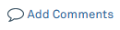 under the Next Steps window on the left side of the Compliance Activity Page. Alternatively, Compliance team member contact information is available on the IRB Office website Contact Us page at
https://irb.northwestern.edu/about/contact-us/ on the Compliance and Education tab.
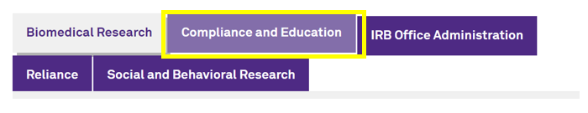

Accessing the Notification Letter
- The notification letter should arrive in the PI and PI Proxy’s email inbox.
  - The Primary Contact for the IRB Project will initially be listed as a PI Proxy for the Compliance Activity.
  - If the notification letter did not appear in the email inbox:
    - Check that the correct email address is listed in the eIRB+ profile.
    - Submit an eIRB+ Support Form request.
- The notification letter can also be found in the History tab of the Compliance Activity.
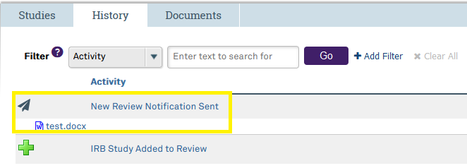

Reviewing the Notification Letter
- The notification letter will reflect the letter that was sent in the email and include information about the post-approval monitoring activity.

Pre-Submission State
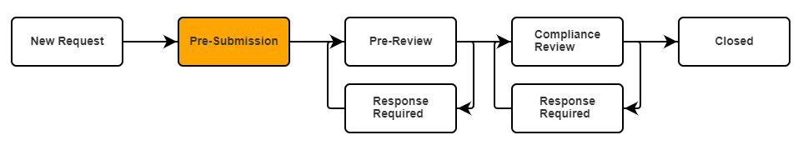
- The Pre-Submission state is pending action/response from the PI or PI Proxy/ies to move forward in the Compliance Activity. When the Compliance Activity is first accessed via the notification email hyperlink or by navigating to the eIRB+ Compliance Workspace, it will be in this state.

Completing the PAM Assessment Checklists

View Edit/Checklists
- Select the View/Edit Checklists button under the Studies tab on the Compliance Activity page to view and complete the Post-Approval Monitoring Assessment Checklist(s). This will open the Post-Approval Monitoring checklist(s).
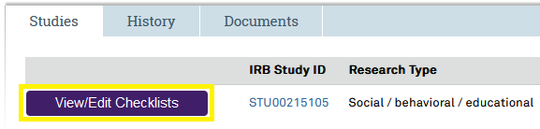
  - The type of checklist that must be completed varies for each study. The checklist(s) required for the study will be predetermined in eIRB+. In some cases, checklists will be determined based on the study status, such as the Participant File Checklist (HRP-428). In other cases, it will be determined based on the study attributes, including but not limited to if it is a clinical trial, relies on an external IRB, has no expiration date, etc. These checklists can be utilized by study teams outside of a Compliance Team-initiated Post-Approval Monitoring activity, and it is recommended that the study team use the forms after the first participant has been enrolled to ensure their research records are compliant. The Post-Approval Monitoring checklists are available for use at any point and are readily accessible on the IRB Office website.
- Respond to the items in the checklist. Read through and follow the instructional text in the PAM Checklists within the eIRB+ Compliance Workspace.

Using the Navigation Panel
- The Navigation Panel is located at the top and bottom of each checklist page.
- The Back button 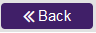and Continue button allow the user to move forward or backward through the checklist pages.
    - The Back button will go back to the first page that has validation errors. It will not always go back to the page directly before the one the user is currently on.
    - The Continue button will only take the user to the next page if the current page is complete and showing no validation errors.
    - Validation errors are error warning messages that will appear when required items are not completed appropriately.
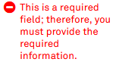
  - Selecting the Save icon will save the study team’s progress.
  - The Hide/Show Errors icon will toggle validation errors. Selecting the Hide/Show Errors icon will switch between showing and hiding the validating errors. Validation error messages will appear in the bottom half of the page window.
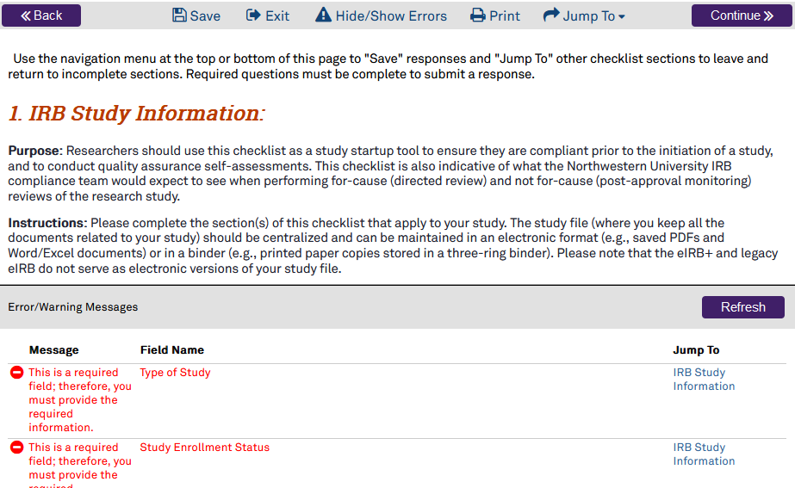
    - The Refresh button will refresh the Error/Warning Messages.
  - The Print icon 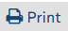 will allow the user to print or save a PDF of the current page they are on.
    - Selecting the Print icon will show a Print Preview page.
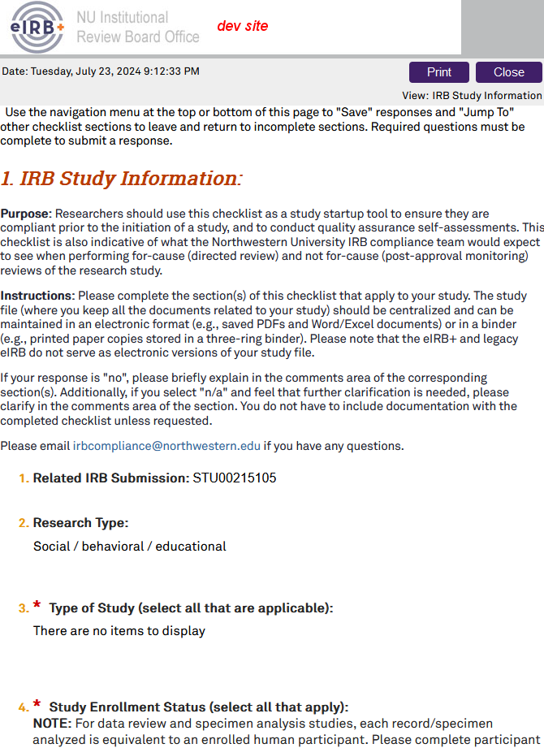
      - Selecting the Print button will open the print screen so that the user can choose to print or save a PDF copy.
      - Selecting the Close button will take the user back to the checklist page they were on.
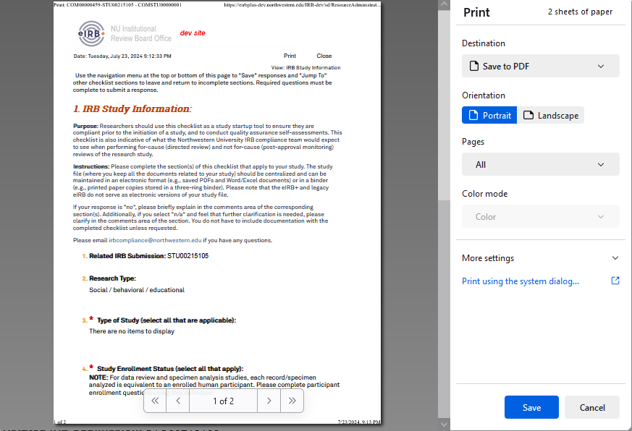
  - The Jump To icon will allow the user to navigate to any checklist page regardless of validation errors.
    - Selecting the Jump To icon will display the full list of clickable checklist pages for the user to select.
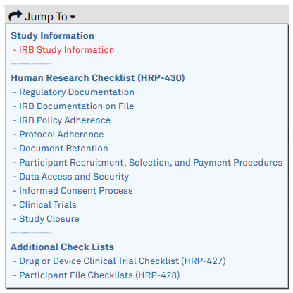

Checklist Functions
  - The red asteriskmeans the field is required.
    - Selecting the Continue button in the Navigation Panel at the top right or bottom right of the page without completing the required fields, the system will not allow the user to continue, and each required field on the page will now be followed by red text stating, “This is a required field; therefore, you must provide the required information.”
    - Selecting the Jump To icon in the Navigation Panel at the top or bottom of the page will allow the user to leave the page they are currently on and jump to another desired section even if the user has not completed all the required fields.
eIRB+ Compliance Tip: The information previously entered on the page before jumping to another section without selecting the Save icon will not be lost; however, it is highly recommended to save often to avoid potentially losing responses.
    - Reach out to the assigned Compliance Analyst or email irbcompliance@northwestern.edu with any questions about how to answer an item.
  - The Finish button 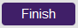 will appear at the end of the checklist. Select Finish when the checklist is complete to return to the main Compliance Activity page.

Submitting the Checklists
- Once finished with completing the self-assessment, the study team is ready to submit the response back to the IRB Compliance Team. Click on Submit Response under Next Steps on the left side menu of the main Compliance Activity page.
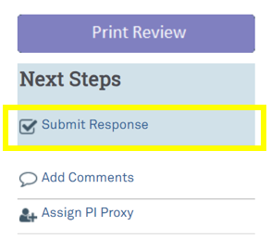
  - If all the required items are not complete before trying to submit the response to the IRB Compliance Team, a pop-up window will appear with a list of error/warning messages for all required items that are missing a response. This pop-up window will list every required item that needs to be addressed.
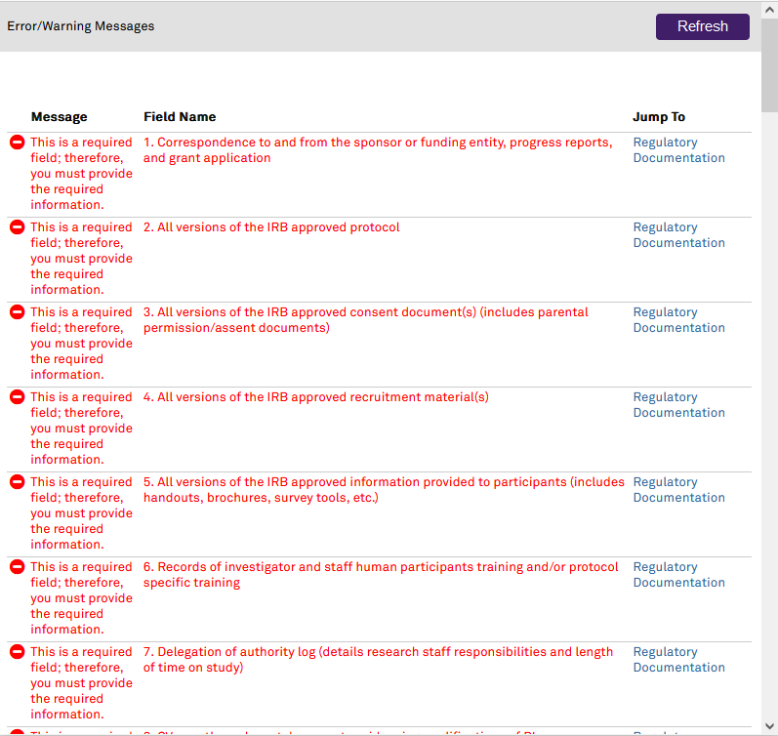
- The PI may delegate PI Proxies to attest that the information provided is true and accurate on behalf of the PI. However, the PI is ultimately responsible for the information provided. A new window will pop up for the PI or PI Proxy to attest to the accuracy of the assessment. Click on the checkbox to confirm attestation and the OK button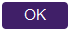 to return to the main Compliance Activity page. A notification will be sent to the Compliance Analyst informing them that the Compliance Activity has been submitted for review. The Compliance Activity will no longer be found in the study team’s Compliance Inbox. It will now appear in the My Reviews or All Reviews tabs within the Compliance Workspace. This will end the Pre-Submission state, and the Compliance Activity will enter the Pre-Review State.
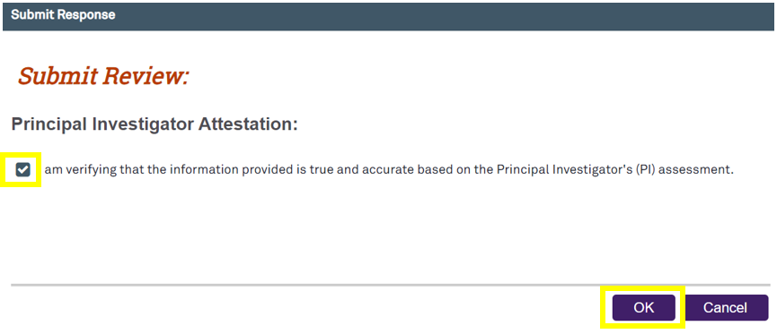

eIRB+ Compliance Tip: Forgot to include some additional information, but already submitted the review?
Users may add comments to the Compliance Activity using the Add Comments icon under Next Steps on the left side menu of the Compliance Activity Page. Users may also email the Compliance Analyst assigned to this Compliance Activity or the IRB Compliance Office.

Pre-Review State
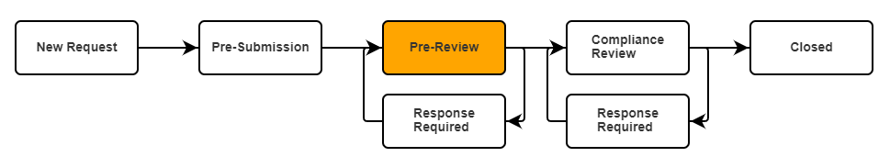
- The Pre-Review state is a state for the Compliance Analyst to ensure the checklists are completed, review the study, ask questions, collect information, and provide observations prior to the comprehensive Compliance Review state, where they provide the researcher with required and/or recommended follow-up actions.
  - The user can still find the Compliance Activity under the My Reviews and All Reviews tab when they first log into the Compliance Workspace.
  - If the PI or PI Proxies need to add additional information after they submit the Compliance Activity back to the Compliance Analyst, they should access the Compliance Activity via the steps above and click on the Add Comments icon on the left side menu to add the additional information.
- A Compliance Analyst will review the responses in the eIRB+ Compliance Workspace and will send the activity back to the investigator with questions or required actions. If there are no observations or actions for the investigator to take, the Compliance Analyst will send a closure notification.

Response Required (Pre-Review State)
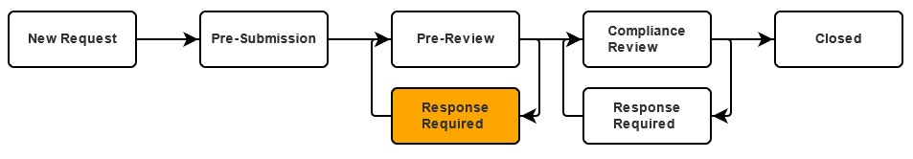
- Once the Compliance Analyst has completed their pre-review and returned the Compliance Activity, the PI and PI Proxy/ies should receive an email notifying them that the Compliance Activity has been returned.

Responding to Observations (Pre-Review State)
- Once the Compliance Activity has been returned to the study team, the study team can click on the COM ID within the autogenerated email notification or within the Compliance Workspace Inbox tab to access it.
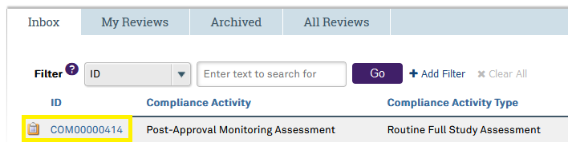
- The observations can be found in the Observations tab of the Compliance Activity.
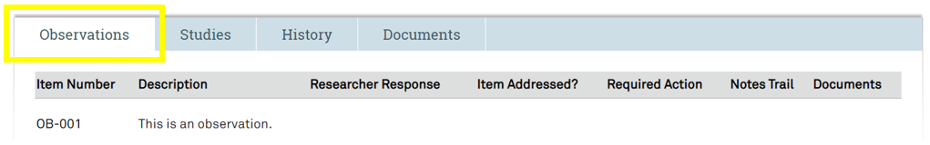
- Click on Respond to Observations 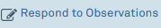 below Next Steps on the left side menu.
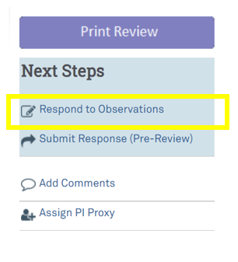
- A pop-up window will appear. Click on each Update button 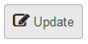 next to each observation to respond.
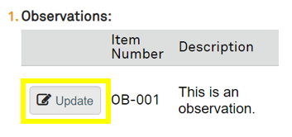
- Another pop-up window will appear to respond to the observation. Within this window, the user may type the response within the Researcher Response textbox and upload any supporting documents by clicking on the Add button 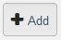 .
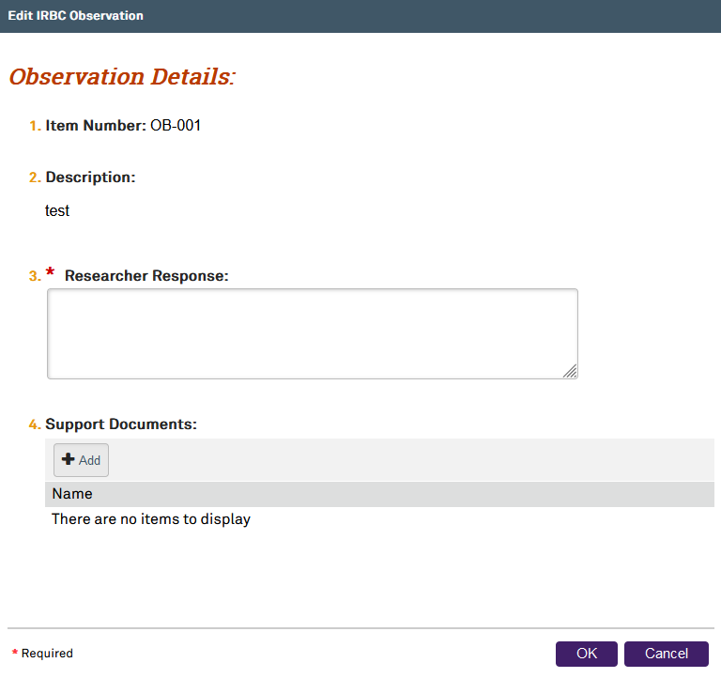
- Click the OK button to continue.
- The user must repeat these steps until they respond to all the observations.

Submitting the Response (Pre-Review State)
- Once all the observation responses have been entered, click on Submit Response (Pre-Review) below Next Steps on the left side menu.
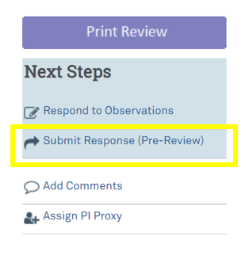
- The PI may delegate PI Proxies to attest that the information provided is true and accurate on behalf of the PI. However, the PI is ultimately responsible for the information provided. A new window will pop up for the PI or PI Proxy to attest to the accuracy of the assessment.
  - If there are observations that were not responded to, the red text will appear below the attestation, noting there are observations missing responses, and the checkbox for the PI’s attestation will be unclickable. The only option is to select one of the Cancel buttons 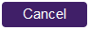 or close the window until every observation has been responded to.
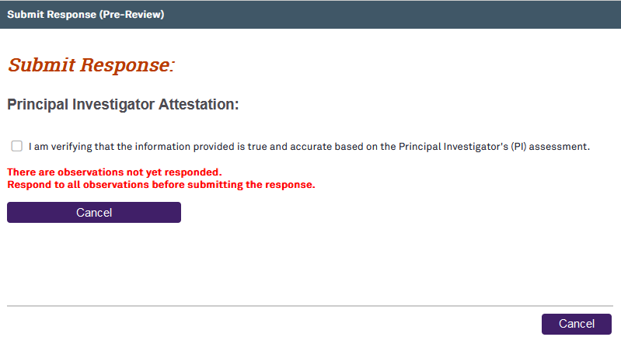
- Click on the checkbox to confirm attestation and the OK button to submit the Compliance Activity to the Compliance Review State and return to the main Compliance Activity page. A notification will be sent to the Compliance Analyst informing them that the Compliance Activity has been submitted for review. The Compliance Activity will no longer be found in the Compliance Inbox. It will now appear in the My Reviews and All Reviews tabs within the main Compliance Workspace page.

Compliance Review State
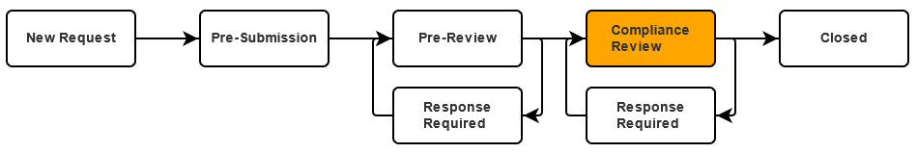
- Once the Compliance Analyst has returned the Compliance Activity, the PI and PI Proxy/ies should receive an auto-generated email from eIRB+ notifying them that the Compliance Activity has been returned. The Compliance Review state is the comprehensive review of the Compliance Activity. The Compliance Analyst will review the responses in the PAM checklists, the response to observations, as well as the study protocol, informed consent forms, etc. to determine whether any actions are required/recommended. In the Compliance Review State, the Compliance Analyst may provide Follow-Up actions, education, best practices, etc. If any response indicates potential non-compliance, the Compliance Analyst will work with the study team to document the event, report the event if it meets IRB reporting criteria, develop a CAPA plan, or take any additional actions. (When a follow-up action of a Modification might be requested).

Response Required (Compliance Review State)
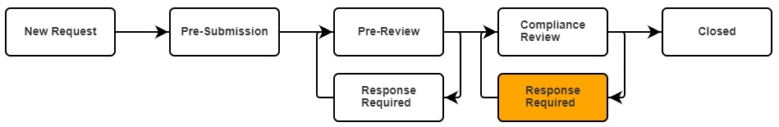
- Once the Compliance Analyst has completed their compliance review and returned the Compliance Activity, the PI and PI Proxy/ies should receive an email notifying them that the Compliance Activity has been returned.
- eIRB+ Compliance Tip: Replying to the auto-generated email notification may result in a delayed response. Contact the Compliance Analyst assigned to the Compliance Activity by clicking on the Add Comments icon under Next Steps on the left side menu. Alternatively, Compliance team member contact information is available on the IRB Office website Contact Us page at
https://irb.northwestern.edu/about/contact-us/ within the Compliance and Education tab.

Responding to Follow-Up Actions (Compliance Review State)
- Click on the COM ID hyperlink in the eIRB+ notification email or within the Compliance Inbox to access the Compliance Activity.
- The Follow-Up Actions can be viewed on the Follow-Up Actions tab of the Compliance Activity. The Follow-Up Actions can only be viewed here. No action can be taken in this section of the Compliance Activity.
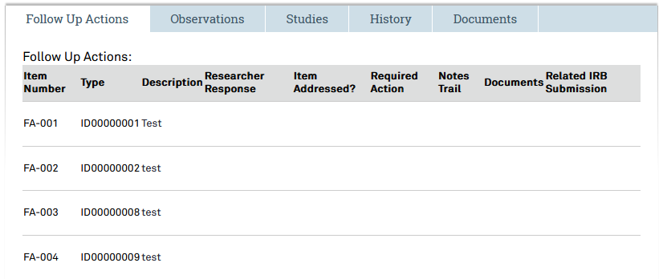
- To respond to the Follow-Up Actions, click on the Respond to Follow-Up Actions icon below Next Steps on the left side menu.
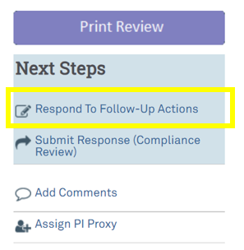
- A new window will pop up. Click on the Update button next to each follow-up action to respond.
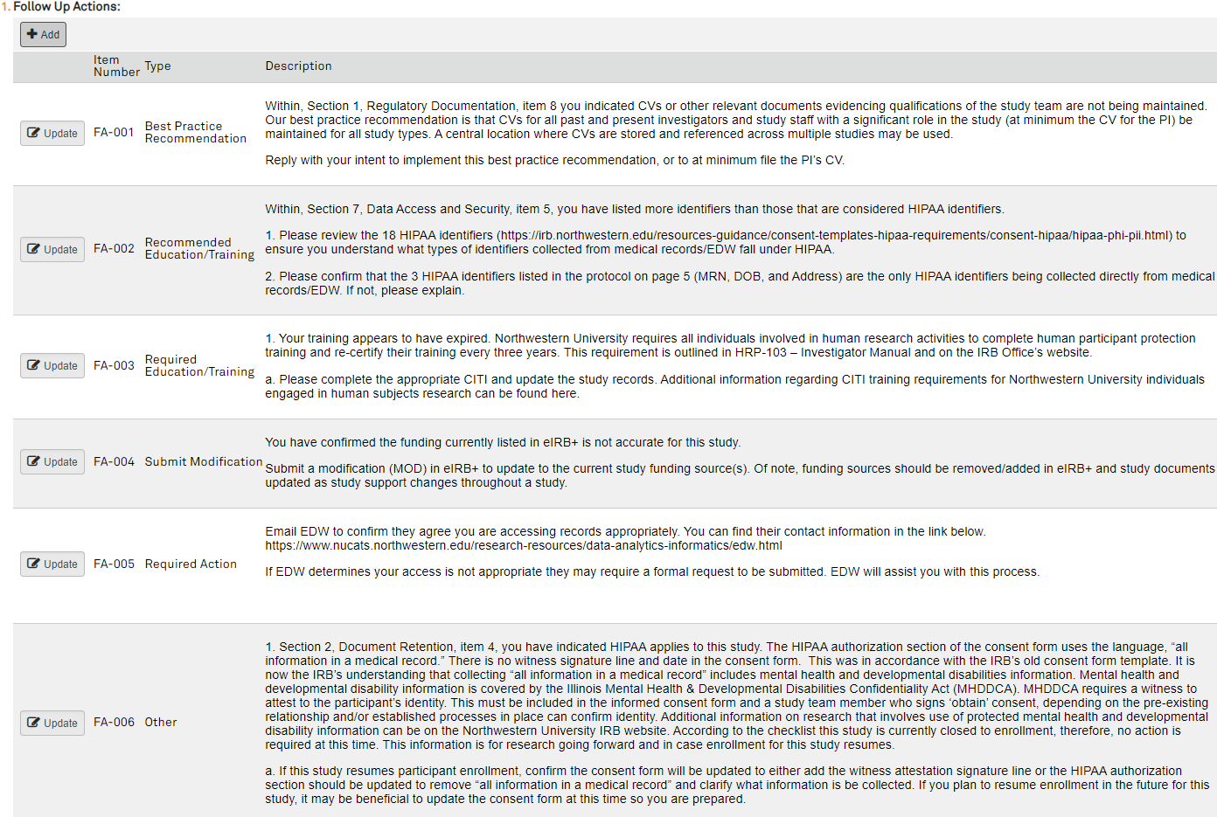
- A new window will pop up. Type a response in the Researcher Response textbox.
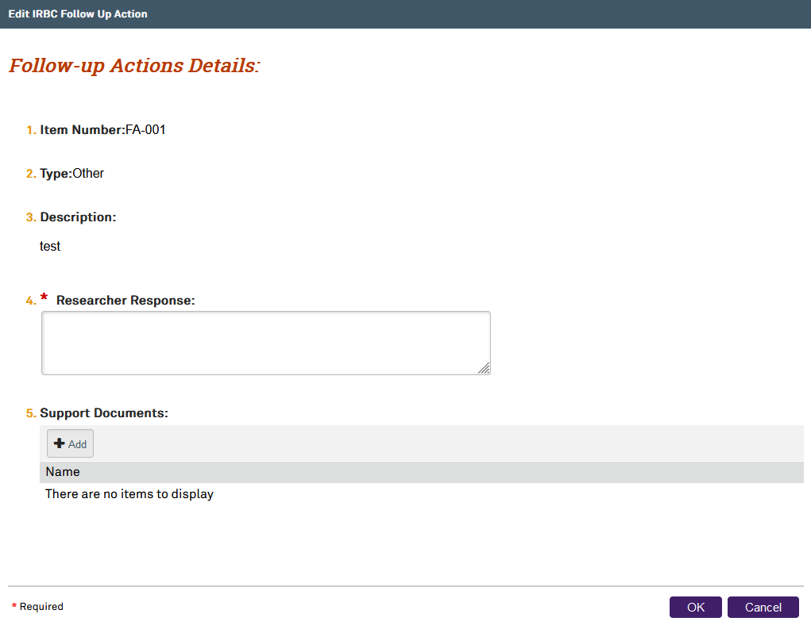
- Add any supporting documents by clicking on the +Add button .
- Click the OK button to continue.
- Repeat these steps for all follow-up actions.
- If the Compliance Analyst asks to submit a Closure, Continuing Review, Modification, or RNI, the required IRB submission will need to be created with eIRB+ prior to responding to the follow-up action. To select a related IRB Submission created to address the request, click on the ellipsis (…) toselect the IRB submission.
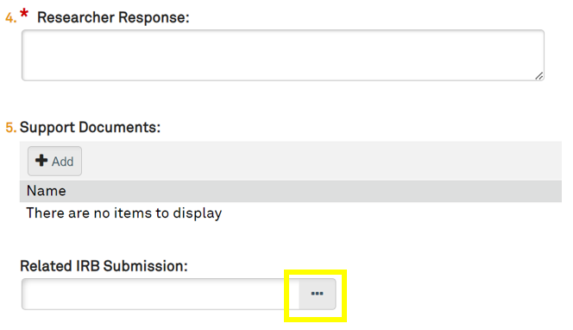
- Click on the OK button to continue and close out of the Related IRB Submission selection window.
- Click on the OK button to continue and close out of the Follow-up Actions Details window.
- Click on the OK button to continue and close out of the Responses to Follow-up Actions window.

Submitting the Response (Compliance Review State)
- Once all the follow-up actions have been responded to, click on Submit Response (Compliance Review) below Next Steps on the left side menu.
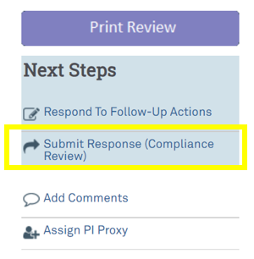
- A new window will pop up for the PI or a PI Proxy to attest to the accuracy of the assessment.
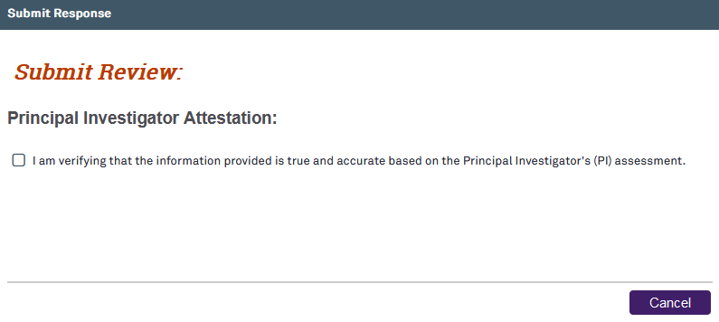
- If all follow-up actions have not been responded to, a red error message will appear. Follow the directions in the Responding to Follow-Up Actions section and return to the Submitting Response section once all follow-up actions have been responded to.
- Click on the checkbox to confirm attestation and the OK button to continue.

Closed Review State
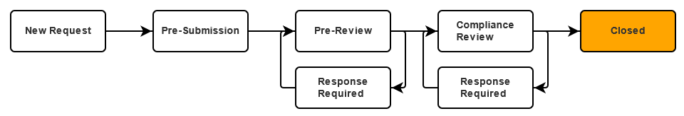
- The Compliance Analyst will close the Compliance Activity and send a PAM Closure Letter once all the observations and follow-up actions have been addressed. Once the Compliance Activity has been closed, an auto-generated email notification from eIRB+ will be sent. The PAM Self-Assessment Activity is now complete.

Accessing Completed Compliance Activities
- To access any completed compliance activities, click on the Compliance tab when logged into eIRB+.
- Click on the Archived tab. The COM ID may be entered into the search box and click the Go button or scroll down to find and select the correct COM ID.
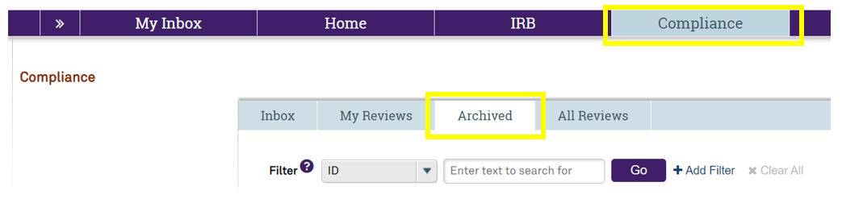

Accessing the PAM Closure Letter
- The PAM Closure letters generally contain education relevant to the status of the ongoing conduct of the study, such as document retention and study closure guidance and other tailored resources and education. The Closure letter will be available as an attachment in the email notification automatically generated when the Compliance Activity is closed. To access and download the PAM closure letter from the eIRB+ Compliance Workspace, click on the Documents tab.
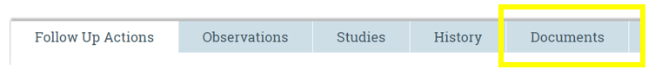
- From there, the study team will be able to download the associated PAM correspondence.
- Note that documents uploaded to observations and follow-up actions are available in the corresponding tabs (i.e., Observations and Follow Up Actions), not in the Documents tab.

Accessing the Compliance Activity Print Review Page
- The Print Review Page will allow the study team to view the entire Compliance Activity on one page.
- From the main Compliance Activity page, click on the Print Review button  on the left side menu. It will take you to the Print Review page, where you can then select the Print button at the top to print the entire Compliance Activity with all the completed checklists.

Saving the Required Documentation from the Compliance Activity
- After the Compliance Activity has been closed, it is required that these records be stored in the research records. Print or save the electronic copies of the notification letter, closure letter, and Compliance Activity Print Review page to the study’s research records. eIRB+ does not serve as an electronic version of the study files. The regulatory binder (where all documents related to the study are kept) should be centralized and can be maintained within an electronic format (saved PDFs and Word/Excel documents) or within a binder (printed paper copies). See the IRB Office’s Study Support Resources and Templates Page for the Regulatory Binder and Research Record templates.
  - The Print icon will allow the user to print or save a PDF of the current page.
    - Selecting the Print button will go to a print preview page.
      - Selecting the Print button will open the print screen where the user can choose to print or save a PDF copy.
      - Selecting the Close button will return to the checklist page.

